Ever since I was little I always wanted to be in the medical field. I also always enjoyed helping people. I remember when I was a Girl Scout I had to do this exercise and make a business card about anything. So my business was all about helping people in need. It wasn’t until high school I decided to go into nursing. I chose nursing because as a doctor I noticed they don’t spend as much time with the patients as nurses do. I’d rather spend my 12 hours with a couple patients and know as much about them as I can and make them feel the best they can when they are very ill. All though this job may make you want to pull your hair out, the moments where he patients or family members that are appreciative make this job worth it.
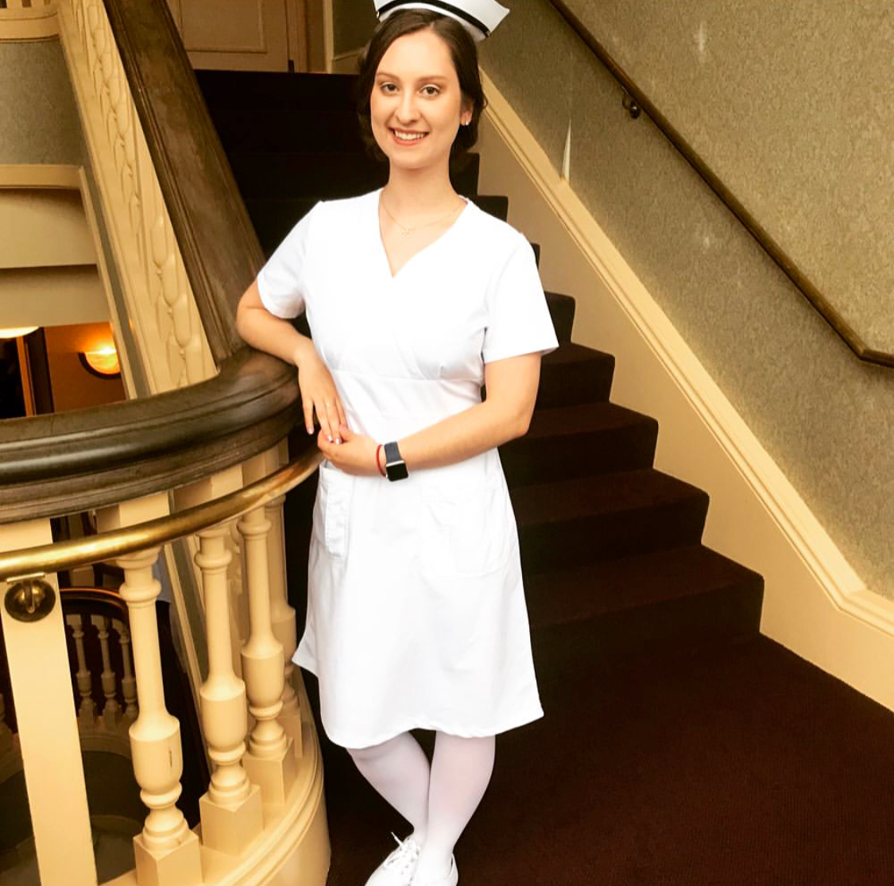
Ashley Delserro BSN, RN

