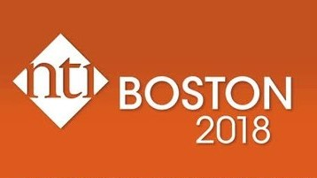

$250 NTI Scholarship

Sponsored by Great Basin AACN

Great Basin AACN sponsors 2 scholarships annually to assist members experience NTI. The Essay Contest is open to all Great Basin AACN members attending NTI. Members are invited to submit a 500-word maximum essay using the “Contact us” link at the bottom of our GB webpage by **March 16th deadline**. (We recommend using the copy/paste function so you have a copy of your submission.) Winners will be notified at our Sepsis Management Event, April 12, at 6 PM at FEAST. Winners must be willing to speak at the GBAACN Fall event (TBA). (GB Board members are available to assist in developing your talk).

The essay contents should cover the following topics:

* Why do you want to attend NTI?
* What topics are you most interested learning about?
* How you will bring this information back to the community?

