
Save the Date

Dinner Lecture:
Identification of Delirium vs Frontal Temporal Dementia

Presented by: Stacy Vitale DO, FACN
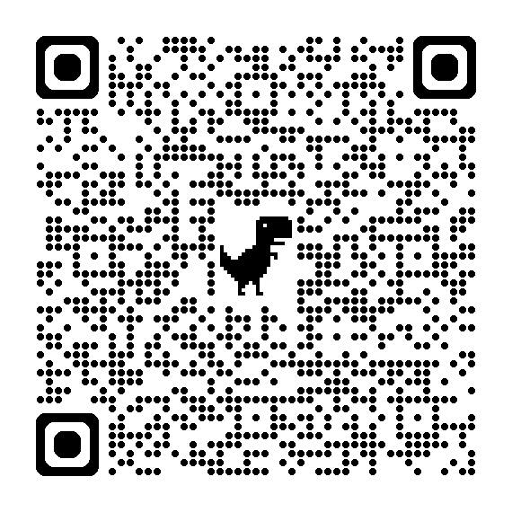

Date: October 6, 2026
Time: 7 PM
Where:
Tap Room

919 Franklin Ave
Garden City
Price: $45 Member, $55 Non-Members

RSVP BY VISITING
nassauaacn.nursingnetwork.com
or scan the QR code!
Join us
for our upcoming event

