

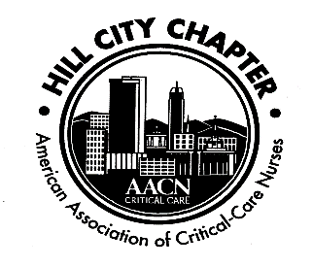

Hill City Chapter of the AACN
November 20, 2017

- Welcome
  - Guided by Why – Meeting started at 1910
- Secretary’s report
  - November 20, 2017 minutes – Please look over minutes
    - Minutes approved with minor changes, adding the new name of conference and Elizabeth Poole as an attendee
      - .
      - .
- Treasurer’s report – Nicole Rodriguez, Treasurer
  - Balances: checking, savings, CD
    - Checking: $18,419.35
    - Savings: $1,613.39
    - CD: $5,018.03
  - Chapter Dues - $15 plus $3.50 nursing network fee
    - National membership is prerequisite to local membership (www.aacn.org)
      - We have membership available for purchase
    - Local dues may be paid on our website (www.aacnhillcity.com) or at meeting by cash or check to “Hill City AACN”
- Recognition
  - Recognition of new certifications
    - Congrats, Beth Furman, CCRN!
  - Chapter funds members’ application fee for CCRN, PCCN or other AACN certification exams
    - We can pay for two attempts – We ask that you reimburse chapter after success. Thank you for returning funds to chapter after being reimbursed by employer. (See Hillary for application)
- NTI 2018 Boston
  - May 20 – 24, 2017
    - Book your room early!
- Save the Dates: Hill City AACN Calendar
  - Monthly meetings 3rd Mondays; 7-9 pm
    - Next Meeting January 15, 2017
    - Planning Meeting for Nursing Summit 2018 at 6pm, 1/15/18
- New Business
  - Bell Ringer – December 2nd, 2017 to call Salvation Army to set up time and place.
  - National Guard Children’s Christmas Party – unable to donate money, but members were able to donate personally.
  - Save the Soaps – Anne Marie to place gift bags in the units for collection of soaps.

