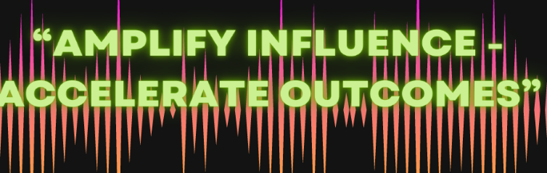
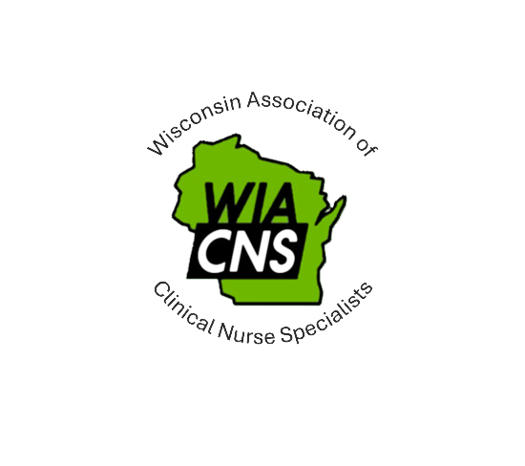

WIACNS Annual Fall

Conference

Waukesha County Technical College

Pewaukee, WI

September 25, 2026, 0730-1600

0730-0755 | Registration/Vendors
0750-0800 | Welcome/Introductions/Plan for the day
0800-0900 | Keynote Address: NACNS President  Jackie Iseler, DNP, MSN, RN, ACNS-BC, CNE, FCNS
0900-0915 | Break/Vendors/Networking
0915-0945 | Improving care for older adults: A clinical nurse specialist led delirium and dementia initiative  Ashley Hachtel, MSN, RN, ONC; Keri Olson, MSN, RN, AGCNS-BC, APNP
0945-1015 | Developing and Sustaining an Evidenced Based Practice Nursing Fellowship Program: A QI Approach to building EBP Capacity and Nursing Scholarship EBP Fellowship  Allison Wier, DNP, RN, APNP, AGCNS-BC; Molly Liddell DNP, RN, APNP, AGCNS-BC
1015-1030 | Break/Vendors/Networking
1030-1130 | Medical Aid in Dying (MAID): A process and pharmacology primer for APRNs  Jennifer Popies, MS, RN, CCRN, AGACNP-BC, ACNS-BC, APNP
1130-1300 | Lunch (on site)/Vendors/Networking & WIACNS General Meeting (1200-1300)
1300-1330 | Addressing Moral Distress and Secondary traumatic stress among hospital nurses  Molly Liddell DNP, RN, APNP, AGCNS-B
1330-1400 | Transplant Trailblazers: Supporting patient education together  Melissa Paulson-Conger, DNP, RN, APNP, CNS-BC
1400-1415 | Break/Vendors/Networking
1415-1445 | Implementing Difficult Intravenous Access (DIVA) score: A pilot project to improve Intravenous Catheter Outcomes  Stephanie Kraus, MSN, RN, ACNS-BC, CCRN
1445-1515 | Normothermia in surgery: Implementation of preoperative warming standards  Lisa Spencer, DNP, RN, CNOR
1515-1545 | ED Care Plans: Impact on ED High Utilization  Tina Nielsen MS, RN, APNP, ACNS-BC
1545- 1600 | Closing Remarks/Wrap up

Contact Hours
5.5 nursing contact hours available, including 1 related to pharmacotherapeutic content*
*Successful completion of the activity will require attendance at the entire activity. Participants who arrive more than 10 minutes late after the start time will not receive nursing contact hours.

Please contact Anne Putzer at anne.putzer@froedtert.com for any questions.

Froedtert & the Medical College of Wisconsin is approved as a provider of nursing continuing professional development by the Wisconsin Nurses Association, an accredited approver by the American Nurses Credentialing Center’s Commission on Accreditation.
Froedtert & the Medical College of Wisconsin is the approved provider of contact hours for this activity in a joint provider agreement with Wisconsin Association of Clinical Nurse Specialists (WIACNS).

