Flamingo Flocking Fundraiser

What is a Flamingo Flocking Fundraiser?
- An individual or group of individuals can have a friend’s home flocked for a fee.

How does it work?
- Announce your upcoming Flamingo Fundraiser and have members get pre-orders from supporters to have one or more of their friends “flocked”.
- In the dead of the night, your members place the flamingos in the yards of the friends that all of your supporters paid to have “flocked”.
- Each of the flocks will have a note explaining how a friend of theirs paid to have them “flocked” in support of your fundraiser.
Tell me about BVAACN Flamingo Flocking Fundraiser!!
- The date the fundraiser begins is March 19 and concludes March 31.
- Members will pre-sell 1-2 flockings for a fee of $40/flocking.
- Flocking forms will be available through BVAACN (Nursing Network).
- The deadline to sell flockings will be March 6, 2018.
- Chapter member will collect payment and submit to a flocking committee member(listed below).
- BVAACN will schedule the flockings.
- A flock consists of (10) flamingos.
- Four to five yards will be flocked per day.
- The flock will nest for 24 hours (7am until 7am).
- Chapter members (BVAACN Flamingo Handlers) will volunteer to deliver and retrieve the flock.
- Flamingo handlers will receive a complimentary t-shirt.

What is BVAACN’s goal with this fundraiser?
- Our dollar amount goal is $2500.
- The monies raised with this fundraiser will be utilized in the professional education and development of critical care nurses in our community and assist in the financial needs of our growing organization.

Contact the following members if you wish to assist in any capacity.
- Mary Menjares / Janie Bohne – sponsorships
- Lisa Strickland / Michelle Hallford – yard signs and t-shirts
- Lolita Flores – video marketing
- Barbra Reed – forms
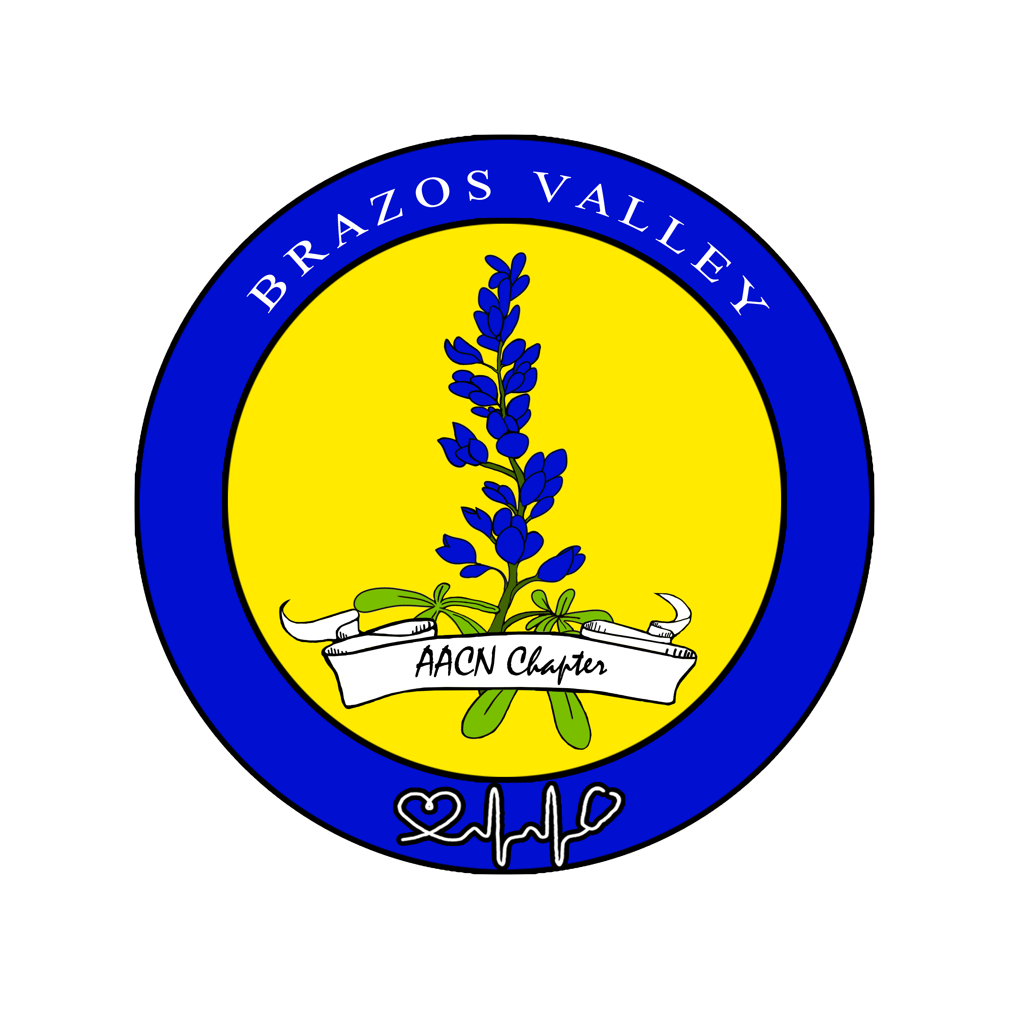
- Edith Muehlstein / Tae Hwang-Lemos / Leslie Gomez – scheduling and payments

Thanks for Your Volunteerism!!

