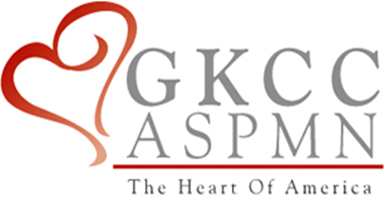

Greater Kansas City Chapter of the American Society for Pain Management Nursing

Presents

Morgan R. Emmendorfer, PharmD

Alaina “Lainie” Linafelter, PharmD

Kristin M. Wiegert, PharmD

**Using IV Tylenol, Ketamine & Lidocaine Therapy**

**to Treat Pain in Pediatric Patients**

**Thursday, March 1, 2018**

**5:30 p.m. – Chapter meeting and dinner**

**6:00 p.m. – Program**

University of Kansas Medical Center Indian Creek Campus,

10720 Nall Avenue, Overland Park, KS 66211 ICC CBO Conference Room 1

Register on our Website www.**gkccaspmn**.com

ASPMN Members: Free Non-Members: $10 Students: $5

**Objectives:**

1. Discuss the effectiveness of IV Tylenol to treat pain in pediatric post appendectomy patients.
2. Discuss the use of IV Ketamine for pain management at Children’s Mercy Hospital.
3. Discuss Lidocaine infusion therapy for pain management in pediatric patients.

Greater Kansas City Chapter of the American Society of Pain Management Nursing is approved as a provider of continuing education by the Kansas State Board of Nursing. This course offering is approved for 1.2 contact hours applicable for RN, LPN, or LMHT relicensure and 1.2 pharmacy contact hours for APNs. Kansas State Board of Nursing provider number #LT0279-0412GKCC151.