

RMPANA Volunteer Opportunity – Feed the City Littleton: Making Meals for People in Need
on Saturday, June 13th, 2026

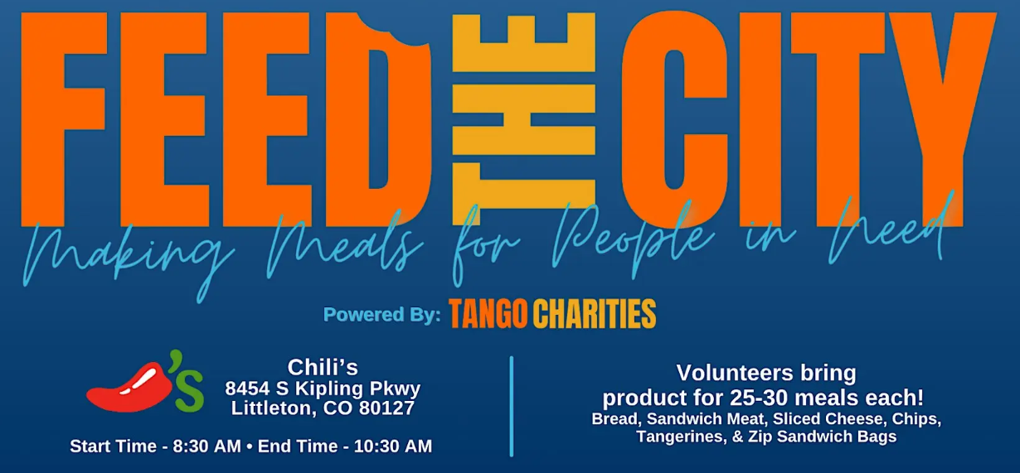

RMPANA will donate food items for members to make bag lunches, but this volunteer activity is open to all! If interested in bringing additional family or friends please email Micah, the RMPANA Volunteer Coordinator, for more details. Members - sign up at RMPANA.com

HUNGER IN AMERICA: In America, over 46 million people live under the shadow of food insecurity. Hunger is a widespread issue all too often masked by pride, but its effects pervade all areas of life. Prolonged micronutrient deficiency leads to a weakened immune system, stunted growth, reduced cognitive ability, chronic disease, and even death.

