Kentucky Society of Perianesthesia Nurses  “Advancing Safety. Strengthening Practice”  PROGRAM TOPICS  Program Topics Include:  • Endoscopy  • GI Bleed: A Simulation Experience  • Redefining Malignant Hyperthermia: Current Trends, Triggers, and Treatment Challenges  • A Risk Management Perspective: Clinical Practice, Documentation, and Litigation  • Beyond the Incision: Psychiatric Safety, Trauma-Informed Communication, and Medication Management in Surgical Care  • Chronic Occupational Stress |  |  | Register @ KSPAN Spring Conference | The Kentucky Society of Perianesthesia Nurses | Nursing Network  KSPAN Members $75  Non Members $65  Online $55  Students $20
  Cancellation Policy
  All registration fees will be fully refunded. KSPAN reserves the right to substitute speakers.
  Contact Us
  Phone: 502-298-5295
  Email: lavettacarney@gmail.com
  Web: The Kentucky Society of Perianesthesia Nurses | Nursing Network
  
  “Advancing Safety. Strengthening Practice”
  2026 KSPAN Spring Conference
  March 21, 2026
  08:00 – 16:45
  UofL Health Mary & Elizabeth Hospital
  1850 Bluegrass Avenue,
  Louisville, KY 40215
  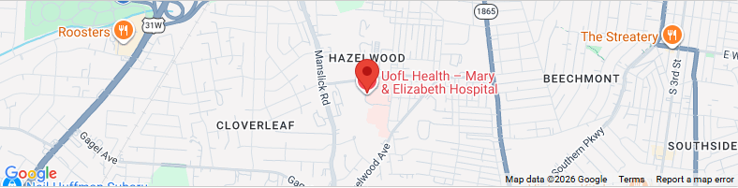
  Advancing knowledge. Supporting nurses. Promoting patient safety.

Target Audience  Registered Nurses, Perianesthesia, perioperative, procedural, and acute care nurses, and Nursing students and nurse leaders.  Outcome  To enable the nurse to increase knowledge on endoscopy procedures, GI Bleed, malignant hyperthermia, risk management, beyond the incision, and chronic occupational stress demonstrated by 80% or more of the participants scoring 80% or higher on the post test.  Accreditation  This activity has been submitted to the American Society of Perianesthesia Nurses for approval to award contact hours. The American Society of Perianesthesia Nurses is accredited as an approver of nursing continuing professional development by the American Nurses Credentialing Center’s Commission on Accreditation.  For more information regarding contact hours please contact the nurse planner LaVetta Carney at lavettacarney@gmail.com  Standards for Integrity and Independence  The provider will collect information from all individuals in a position to control content regarding financial relationships with ineligible companies, analyze the data for relevant financial relationships related to the educational content; and mitigate relevant financial relationships. The results of this analysis will be reported in the course presentation materials on the required handout. |  |  | SCHEDULE  07:30 – 08:00 Registration  08:00 – 09:00 Endoscopy Procedures Erin Wood, BSN, RN, CGRN  09:00 – 11:00 GI Bleed: A Simulation Experience Dr. Katherine Simpson, DNP, MSN, APRN-BC, CNRN, CVRN-II, LNC  11:00 – 12:00 Lunch  12:00 – 13:00 Redefining Malignant Hyperthermia: Current Trends, Triggers, and Treatment Challenges Teresa Dudley-Garrett, MSN, RN, CPAN  13:00 – 14:00 A Risk Management Perspective: Clinical Practice, Documentation, and Litigation Charles Helm, BSN, RN, CMCN, CCDS Kimberly Williams, BSN, RN  14:15 – 15:15 Beyond the Incision: Psychiatric Safety, Trauma-Informed Communication, and Medication Management in Surgical Care Dr. Karla Hopkins, DNP, MHA, APRN, PMHNP-BC  15:30 – 16:30 Chronic Occupational Stress Dr. Shaquilla Cooper, DSW, CSA-S, LCSW-S |  |  | CONFERENCE OVERVIEW  Program Description  The Kentucky Society of Perianesthesia Nurses (KSPAN) is pleased to present a full-day educational conference designed to enhance clinical knowledge, professional practice, and personal well-being for nurses across perioperative and perianesthesia settings. This conference provides evidence-based education, practical application, and interdisciplinary perspectives to support safe, high-quality patient care.

