
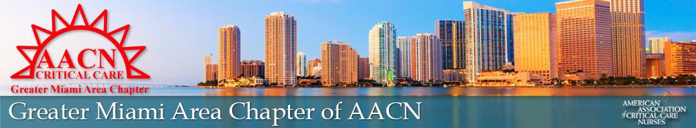
The Greater Miami Area Chapter
Of the American Association of Critical Care Nurses Proudly Presents The 37th Annual

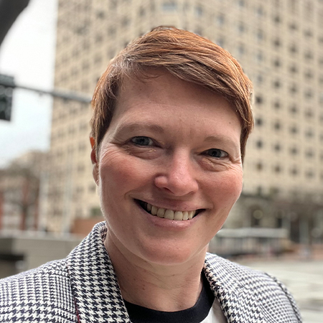
Miami Teaching Institute

Friday March 13, 2026
Newman Alumni Center
University of Miami Campus 7:00AM – 3:30PM
6200 San Amaro Dr.
Coral Gables, FL 33146
Fees include breakfast, lunch, and parking
Keynote Speaker:
Rebekah Marsh, BSN, RN, CCRN
AACN President

Registration
$110-AACNMembers (Must present ID Card)
$135-Non-AACN Members
$60-Unlicensed Undergraduate Nursing Students (with valid student ID)
$160–At the Door-AACN & Non-AACN Members
Register via our website: www.criticalcaremiami.nursingnetwork.com
REFUNDS WILL NOT BE ISSUED AFTER March 6,2026
Excluding a $20 processing fee, will be given only if requested via email or phone listed below by March 6, 2026
Carline Wade
(786)295-8553 or miamiareachapter@gmail.com
VENDOR FAIR
Meet our local medical companies and see new technologies available to make your job easier

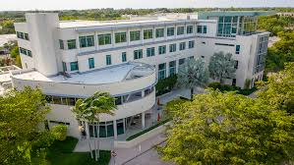
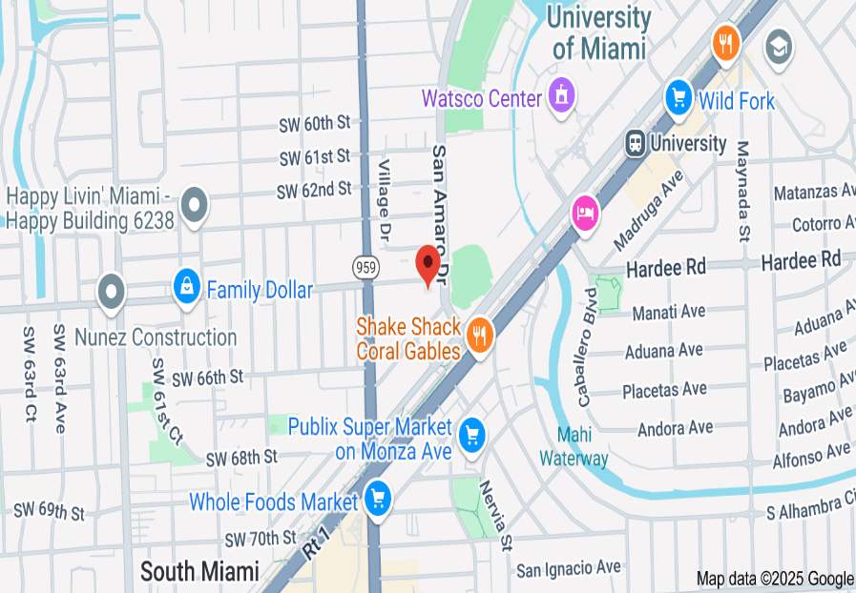
Time | Presentation
7:00am–8:00am | Registration, Exhibits & Welcome  Vianney Rosales 2025-2026 GMAC President
8:00am–9:00am | On Purpose  Rebekah Marsh, BSN, RN, CCRN
9:00am–10:00am | Request for Qualitatively Futile Therapy  Dr. Eduardo Martinez DuBouchet, MD
10:00am–10:45am | Breaks/Exhibitor
10:45am–11:45am | The Art of ECG Interpretation  Rebekah Marsh, BSN, RN, CCRN
11:45am–12:15pm | Poster Presentations
12:15pm–1:15pm | Lunch, Vendor, & Networks
1:15pm–2:15pm | Pediatric Dermatological Conditions  Dr. Jill S. Waibel, MD
2:15pm–3:15pm | Antibiotics, Infection, and the Evidence: Update 2026  Douglas Houghton, DNP, APRN, CCRN, NEA-BC, FAANP
3:15pm–3:30pm | Wrap-up, Raffles & Evaluations

Research &
Performance
Improvement
Poster
Presentations
5.5 CEUs
Will be Awarded
To attendees
www.criticalcaremiami.nursingnetwork.com

