SKIN SAFETY IN THE OR: PREVENTING PERIOPERATIVE PRESSURE INJURIES
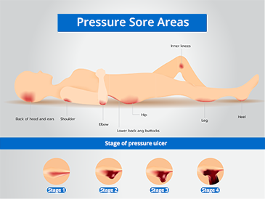
AORN of Central Pa #3908
Virtual meeting, January 13, 2026, 7:00 PM
Sponsored by Mölnlycke
1.0 CE available
Participants must attend the course and complete the post-test to receive the CE.
If you do not have a clinical learning hub account with Mölnlycke, please create an account in advance of the virtual meeting to obtain CE. https://us.clinicallearning.com

