AORN
FALL education
Please join us for a lovely evening reviewing the Irrisept Antimicrobial Wound Lavage  - FREE CE presentation!  - Appetizers Provided!  - Great company!  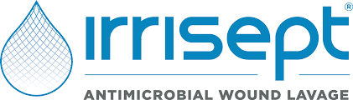 |  | October 9th  5:30-7:30 pm  @ The Liberal CUP  Located at 115 Water street #1, Hallowell, mE

