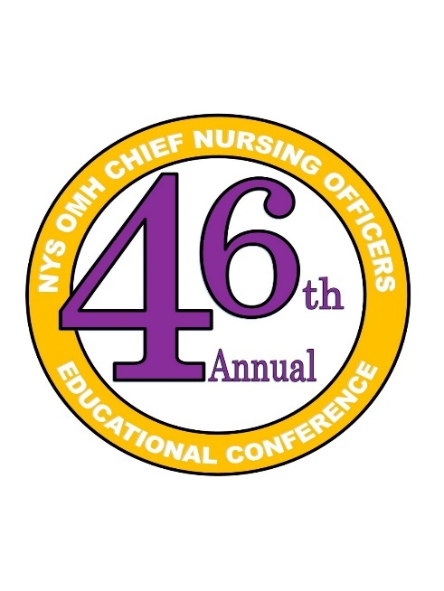
2025 CNO Annual Educational Conference:
Integrating Caring Science to Foster Organizational Wellness and a Culture of Compassion

Schedule of Presentations

DAY 1
Wednesday, November 5, 2025
7:30 – 8:30 am Registration
8:30 – 9:00 am OPENING REMARKS:
Welcome Message
Maxine Smalling, MS, BSN, RN, Chief Executive Nursing Officer, State Operations and Community Health, NYS OMH
Dr. Martha Carlin, PsyD, Associate Commissioner, Division of State Operated Services

9:00 – 10:00 am Plenary: Topic: Building Wellbeing: The Power of Story
Presenter: Susan W. Blaakman, PhD, RN, PMHNP-BC
Host: Juanita Goyette, RN, PMH-BC, Caritas Coach, and Collette Lozoff, BSN
1.0 Contact Hours

10:00 – 10:15 am Break/Visit Exhibit Hall

10:15 – 11:15 am Plenary: Topic: Resiliency Informed Care: Improving Wellness in Individuals, Communities, and Organizations
Presenter: Allyson Neal, DNP, PMHNP-BC, Child & Adolescent Psychiatric CNS-BC, PNP, APNA President
Host: Maxine Smalling, MS, BSN, RN, Chief Executive Nursing Officer,
State Operations and Community Health
- Contact Hours

11:15 am – 12:15 pm Visit Poster Presentations
Hosts: Tracey L. Mason, MS, RN, PMH-BC-NEA-BC, CNO, Western NY CPC; Martine Sainvil-Wilson, MSN, RN, CNO Bronx PC
Title of Poster: Promoting Caring Communication Among Nurse Leaders
Presenter: Tracey L. Mason, MS, RN, PMH-BC-NEA-BC, CNO, Western NY CPC
0.25 Contact Hours
Title of Poster: Incorporating Self-Care Micro-Practices Using the First Caritas Process®
Presenter: Karen Accurso, DNP, RN, CNO, Mid-Hudson Forensic PC
0.25 Contact Hours
Title of Poster: Nurses Honor Guard: Helping with Transition
Presenter: Juanita Goyette, RN, PMH-BC, Caritas Coach
0.25 Contact Hours
Title of Poster: Loving Kindness Micro-Practices in Team Meetings
Presenter: Shyla Roshin, DNP, RN, CNS, ANP-BC, CNO, SBPC
0.25 Contact Hours

12:15 – 1:15 pm Lunch
Hosts: Collette Lozoff, BSN, RN; Suzanne O’Neil, MSN, MA, BS, RN, CNO Pilgrim PC;
Karen Accurso, DNP, MSN, RN, CEN, CNO Mid-Hudson PC; Lalu George, MS, RN, CNO Rockland PC
1:15 – 1:45 pm Plenary: Topic: The RPMs “Revelations Per Minute” Wellness Program
Presenter: New York State Psychiatric Institute: Rebecca A Owens, DNP, MBA, MSN, RN, PMH-BC, FAAN, CNO NYSPI; Alexandra Burikova, MS, RN; Christine McManus, MS, RN
Host: Collette Lozoff, BSN, RN
0.5 Contact Hours

1:45 – 2:15 pm Plenary: Topic: RNs in the Milieu – A Caring Science Approach
Presenter: Capital District Psychiatric Center: Wendy Buell, AAS-RN
Host: Monique Stewart, MSN, PMHNP-BC, RN, CNO CDPC
0.5 Contact Hours

2:15 - 2:30 pm Break

2:30 – 3:00 pm Plenary: Topic: Bringing Caring to the Core: Integrating Watson’s Caring Science into Everyday Psychiatric Nursing Practice
Presenter: Pilgrim Psychiatric Center: Joseph DiPrisco, MSN, RN; Heather Ferriolo, MSN, RN; Janice McPhaul, MSN, RN; Christina Wolfle, MSN, RN
Host: Suzanne P. O’Neill, MSN, RN, CNO Pilgrim PC
0.5 Contact Hours

3:00 – 3:30 pm Plenary: Topic: Falls and Prevention Strategies in an Inpatient Psychiatric Setting
Presenter: Kirby Psychiatric Center: Rina Tirabassi-Colaiacovo, RN, PMHCNS-BC, MSN, BSN, CARN; Daniel Livshin, MHA, BHA, RN; Jessica Centeno, RN; Honeybee Valenzuela, RN
Host: Jeanette Bernardino-Pascual, RN, CNO Kirby PC
0.5 Contact Hours

3:30 – 3:45 pm Break/Visit Exhibit Hall

3:45 – 4:45 pm Plenary: Topic: A Journey to Hope and Recovery
Presenter: Juanita Goyette, RN, PMH-BC, Caritas Coach
Host: Collette Lozoff, BSN
- Contact Hours

4:45 – 6:00 pm Visit Exhibit Hall/Poster Presentations

6:00 – 7:00 pm Break

7:00 – 9:00 pm Dinner/Networking

2025 CNO Annual Educational Conference:
Integrating Caring Science to Foster Organizational Wellness and a Culture of Compassion

DAY 2
Thursday, November 6, 2025

7:30 – 8:30 am Registration
8:30 – 9:00 am OPENING REMARKS:
Welcome Message
Maxine Smalling, MS, BSN, RN, Chief Executive Nursing Officer, State Operations and Community Health, NYS OMH

9:00 – 10:00 am Plenary: Topic: Caring Science
Part I: Caring Science/Caritas Practices –Intellectual-Experiential Guide for Personal/Professional Caring for Self
Presenter: Jean Watson, PhD, RN, ANH-BC, FAAN, LL (AAN)
Host: Maxine Smalling, MS, BSN, RN, Chief Executive Nursing Officer
- Contact Hours

10:00 – 10:15 am Break/Visit Exhibit Hall

10:15 am – 11:15 pm Plenary: Topic: Caring Science
Part II: Caring Science/Caritas Practices –Intellectual-Experiential Guide for Personal/Professional Caring for Self
Presenter: Jean Watson, PhD, RN, ANH-BC, FAAN, LL (AAN)
Host: Maxine Smalling, MS, BSN, RN, Chief Executive Nursing Officer
- Contact Hours

11:15 am – 12:15 pm Plenary: Topic: Assessment and Treatment of Co-occurring Disorders
Presenter: Dr. Lisa Marino, Deputy Clinical Director, Pilgrim Psychiatric Center
Host: Suzanne O’Neil, MSN, MA, BS, RN, CNO Pilgrim PC
- Contact Hours

12:15 – 1:15 pm Lunch
Hosts: Collette Lozoff, BSN, RN; Suzanne O’Neil, MSN, MA, BS, RN, CNO Pilgrim PC;
Karen Accurso, DNP, MSN, RN, CEN, CNO Mid-Hudson PC; Lalu George, MS, RN, CNO Rockland PC

1:15 – 2:15 pm Plenary: Topic: A Power Trio: Accountability, Responsibility & Compassion
Presenter: Anita Daniels, MS, RN, PMH-BC
Host: Maxine Smalling, MS, BSN, RN, Chief Executive Nursing Officer, State Operations and Community Health, NYS OMH
1.0 Contact Hours

2:15 – 4:00 pm Visit Exhibits

