Registration Form:  NAME:_______________________________________________  ADDRESS:____________________________________________  EMAIL: ____________________________________________  Check one:  AST Member _____ CST/ ST Non-Member_____  AORN Member____ RN Non- Member____  Student ____  AORN #____________________  CST # _____________________ Certification #: ___________  Where do you work: _____________________________________________  Pay Via:  Please make checks payable to: AORN Chapter 2203  Please mail registration forms to:  STCL & AORN Chapter 2203  ℅ Amy Leigner  47 Nonotuck Rd  West Springfield, MA 01089  Neuro Edge Conference  _______________________________________________________  Presented by:  The Surgical Tech Clinical Ladder  & AORN Chapter 2203  Saturday, September 20, 2025  8:00 am - 1:00 pm (registration opens at 7:30)  Chicopee Castle of Knights  1599 Memorial Drive  Chicopee, MA 01020  4 CEs CSTs  4 CEs RNs  FEE:  $70.00 - AORN Member  $75.00 - Non-Member  $60.00 - Surgical Technologist  $55.00 - AST Member  $21.00 - Students  Breakfast Included - Parking is FREE | 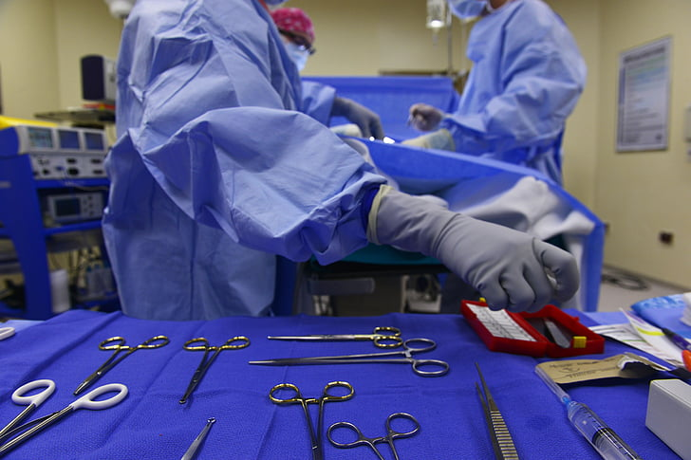  2025 FALL  SURGICAL TECHNOLOGIST CLINICAL LADDER  &  AORN Chapter 2203  CONFERENCE  _______________________________________________________  Neuro Edge  ________________________________________________________  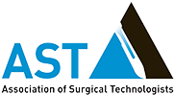  Conference Objectives  - The education seminar seeks to improve the knowledge, theory, practice, and compassion of healthcare providers  - An overview in Cervical Spine Trauma anatomy, pathophysiology, imaging and treatment options  - Gain understanding of Deep Brain Stimulation including all indications, procedures and future advancements  - Discuss advanced surgical treatments for trigeminal neuralgia, including the Jannetta procedure (microvascular decompression), when medications fail  - Understanding key insights on subdural hematoma: imaging findings, surgical indications, post-op complications, and follow-up practices  Conference Agenda  7:30 - 8:00 AM - Registration  8:00 - 9:00 AM - Cervical Spine Trauma  Dr. Robert Schapiro, MD  9:00 - 10:00 AM - Deep Brain Stimulation  Dr. Richard Ogbuji, MD  10:00 -11:00 AM - Breakfast Break  Enjoy a wonderful breakfast  View our Vendor Exhibits and Raffle Table  11:00 -12:00 PM - Jannetta procedure to treat Trigeminal Neuralgia  Dr. Kamal Kalia, MD  12:00 - 1:00 PM - Subdural Hematoma Trauma  Mathew Kele, PA  CE Certificate of Attendance will be handed out at the completion of the conference

