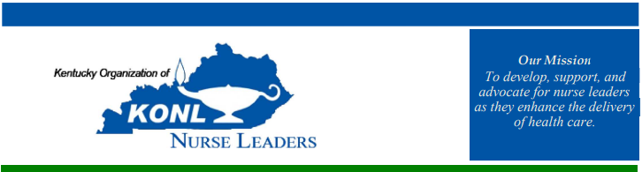

“Nothing About Us, Without Us”
October 23-24, 2025 | University of Louisville Health – Rudd Heart Lung

Thursday, October 23rd
1100-1200 Board Meeting (Lunch Provided) – Sally Davenport, DNP, RN, NEA-BC
1100-1200 Vendor Welcome & Set Up

ALL REGISTRANTS
1200-1230 Registration & Vendors
1230-1245 Welcome – Deanna Parker, MBA, MHA, BSN, RN, Associate Chief Nursing Officer, UofL Hospital
1245-1415 Narrative Nurse Leadership “Story Telling” and Constructs of Authentic Nursing Leadership – Shelly Luger, DNP, RN, NEA-BC and Dana Koziel, DNP, RN
1430-1445 Break w/ Vendors & Posters
1445-1530 Kentucky Nurse Leader Health and Wellbeing Evaluation: Preliminary Results – Sally Davenport, DNP, KONL President
1530-1615 Advocacy in Nursing - Dr. Rachel Culpepper, RN, CENP
1615-1700 Break w/ Vendors & Posters
1800 Social Event – Upland Brewery – Jeffersonville, IN

“Nothing About Us, Without Us”
October 23-24, 2025 | University of Louisville Health – Rudd Heart Lung

Friday, October 24th
0830-0900 Breakfast
0900-0940 Welcome & KONL Business Meeting – Sally Davenport, DNP, RN, NEA-BC
0940-1000 Committee Report Out – KONL Board Members
1000-1030 Break w/ Committee Involvement Opportunities
1030-1115 Stronger Together: Creating a Culture of Wellness and Support – Shari Kretzschmer, MBA, MSN, RN, NEA-BC
1115-1230 Awards Luncheon
1230-1245 Mindfulness Activity – Lindsey Journey , MSW, LCSW
1245-1345 Exploring Healthcare Leaderships’ Morally Distressing Experiences: A Mixed-Methods Approach – Adam Booth PhD, RN, NPD-BC, Mandi Walker, DNP, RN, NPDA-BC, CCRN, NEA-BC, Katie Robinson, PhD, RN, EBP-C, NPD-BC, OCN
1345-1430 Sustaining the Spirit: Self Care as a Path to Nurse Leader Engagement – Mendy Blair, DNP, RN-BC, NEA-BC, CENP
1430 - Closing Remarks – Sally Davenport, DNP, RN, NEA-BC

