

Montgomery County Sheriff Department to present at AORN North Harris Montgomery Chapter 4410

Education Symposium

and

Vendor Fair

Saturday January 27, 2018

9 -11:30 AM

Houston Methodist

The Woodlands

17201 Interstate 45

The Woodlands,Tx 77385

Third Floor Conference Room

Light snacks and beverage

Door prizes

SILENT AUCTION

2 CEs pending

INFO- C Hawks 832-453-500

Silent Auction

(2 Contact Hours Pending)

AORN 4410

EDUCATION SYMPOSIUM January 27,2018

REGISTRATION

Name__________________________________

E-mail__________________________________

Phone__________________________________

Member AORN 4410 - Y N

November 15 - January 20: $35

January 21 - 27 $40

Registration and doors open: 8:30 AM

PROGRAM

Active Shooter 9-10 AM

Street Drugs and Your Patient 10:20 - 11:20AM

Silent Auction Ends 11:20 AM

Door Prize Drawings 11:25 AM

Make checks payable to:AORN 4410

Please mail by January 20

Carol Holder, Treasurer AORN 4410

21594 Rose Mill Drive, Kingwood, Tx 77339

Registration may be given to Chapter Officers

Cynthia Hawks Colleen Canfield

Linda Chevalier Carol Holder

AORN 4410 Education Symposium 2018 ActiveShooter -

Street Drugs and Your Patient

Nunc luctus neque et quam blandit iaculis. Pellentesque aliquam quis ligula quis commodo.

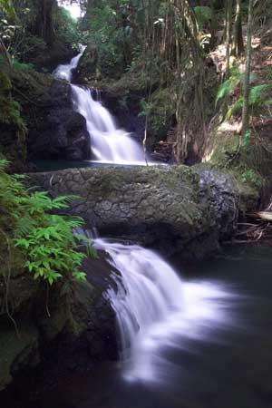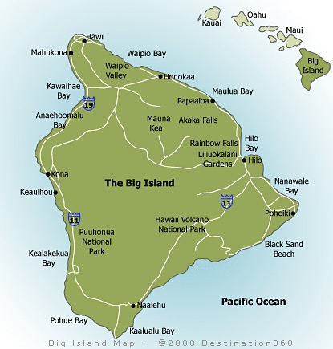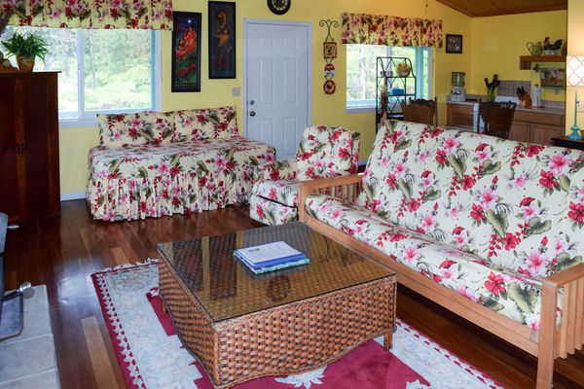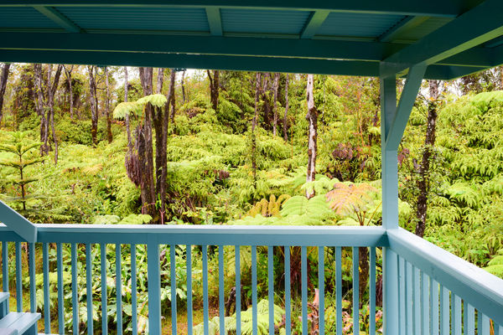

AORN 4410

SILENT AUCTION

ONE WEEK LODGING VOLCANO, HAWAII

HIDE-AWAY

Spend a week surrounded by rainforest.

**Studio plus 1 bedroom - 2 baths on 3 heavily forested acres 7 miles from Hawaii Volcaneos National Park**

45 from Hilo

2 Hours to Kona

“THE BIG ISLAND”

8 of the 11 world climate regions Beach and Snow on the same day!

All funds from Education Symposium and Silent Auction will be used to support chapter delegates attendance at AORN Global Surgical Conference and Expo in New Orleans, March 2018.

**On line bids can be placed on Chapters Facebook Group page - AORN 4410- ask to join group to place bids.**