UPCOMING
“GET IT DONE”
AT
BARBERSHOPS & BEAUTY SALONS
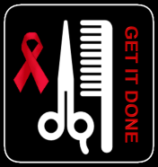
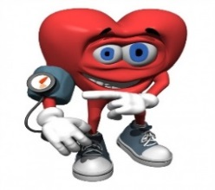
FEBRUARY 10, 2018, 10AM-2PM
VOLUNTEERS ARE NEEDED TO COMPLETE
HIGH BLOOD PRESSURE CHECKS.
Contact Patricia Cathey at patricia.cathey@commongroundhealth.org and/or Phyllis Jackson at phyllis.jackson@commongroundhealth.org for more information.

