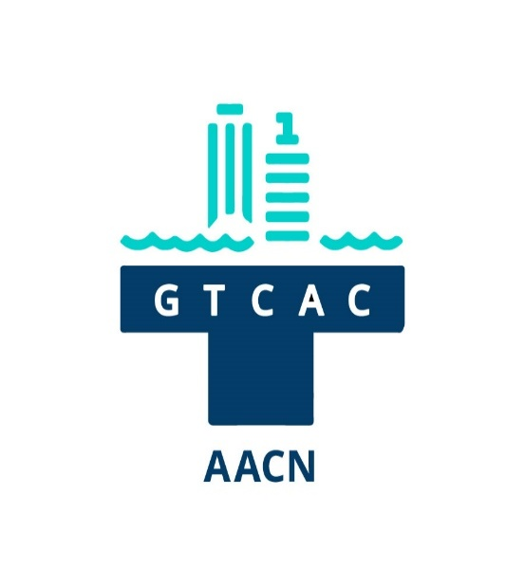
Crossroads: Challenges in Critical-Care Nursing 2025
November 5, 2025, Agenda

0700- Sign-in and breakfast
0725- Welcome and Announcements
0730-0830- Case Studies in Extracorporeal Cardiopulmonary Resuscitation
0830-0930- From Crushed to Collapsed: Behind the Impact Zone of Blunt Thoracic Trauma (Sarah Vance, MSN, RN, CCRN)
0930-1000 Break and visit nonprofit tables and posters
1000-1100 GLP-1’s and GLP-2’s (Gwendolyn Polaski, PA-C)
1100-1200 Cath Lab Case Studies (Jennifer Callear, MSN, RN, CCRN, PCCN, CMC)
1200-1300 Lunch and visit nonprofit tables and posters
1300-1400 Sincerely, Your Flight Crew (Logan Griffis, BSN, RN, CCRN, CFRN; MacKinley Johnson, BA, NRP, FP-C, CCP-C, CNP-T)
1400-1515 Getting to the Heart of ARDS: Clinical Insights and Intervention Strategies (Sarah Vance)
1515-1545 Break and visit nonprofit tables and posters
1545-1645 Reducing Healthcare’s Impact on Climate Change (Evelyn Vigdahl, MSN, RN)
1645 Door prizes

