**Trick or Treat: Unmasking the Best Practices in Occupational Health**

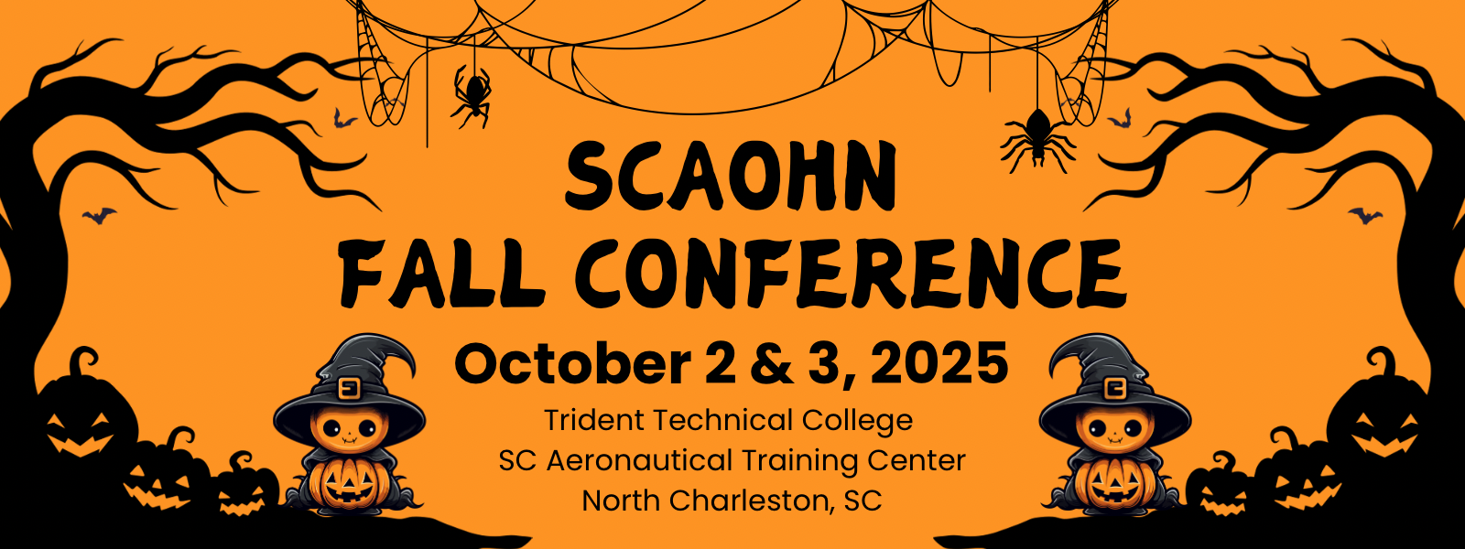

**Thursday, October 2, 2025**

|  |  |
| --- | --- |
| **7:15AM** - **8:00AM** | Registration, Breakfast, & Networking |
|  |
| **8:00AM - 8:15AM** | Welcome |  |
|  |
| **8:15AM - 9:15AM** | Tricks, Treats, & Testimony: OHNs in the Courtroom |  |
| **South Lewis (WJC&B)** |  |
| **9:15AM- 9:45AM** | Break & Visit Vendors |  |
|  |
| **9:45AM - 10:45AM** | Safety Nightmares: Accident Investigation & Recordkeeping that Won’t Haunt You (Part 1) |  |
| **Angie Baldwin (SC OSHA)** |  |
| **10:45AM - 11:00AM** | Brain Break |  |
|  |
| **11:00AM - 12:00PM** | Safety Nightmares: Accident Investigation & Recordkeeping that Won’t Haunt You (Part 2) |  |
| **Angie Baldwin (SC OSHA)** |  |
| **12:00PM - 1:00PM** | Lunch |  |
|  |
| **1:00PM - 2:00PM** | Annual Business Meeting |  |
|  |
| **2:00PM - 3:00PM** | Ghosting Legal Scares: OHNs Returning Injured Workers to Work |  |
| **South Lewis (WJC&B)** |  |
| **3:00PM - 3:30PM** | Break & Visit Vendors |  |
|  |
| **3:30PM - 4:00PM** | Vendor Introductions & Door Prize Drawings |  |
|  |
| **4:00PM - 4:45PM** | Bewitched by Wellness: The Three Therapies of Life |  |
| **Glen Ward** |  |
| **4:45PM - 5:00PM** | Day One Wrap Up & Evaluations |  |
|  |

**SCAOHN Fall Conference 2025**

**Continued**

**Friday, October 3, 2025**

|  |  |
| --- | --- |
| **8:00AM - 9:00AM** | Registration, Breakfast & Networking |
|  |
| **9:00AM - 10:00AM** | ABOHN Specialty Certification: Don't Let It Spook You |  |
| **Dr. Betty Sanisidro (ABOHN)** |  |
| **10:00AM - 10:15AM** | Brain Break |  |
|  |
| **10:15AM - 10:45AM** | Creepin' It Real: Demonstrating Your Worth as an OHN |  |
| **Karen Smith (GPS Jobs)** |  |
| **10:45AM - 11:15AM** | Casting a Spell of Empowerment: Leading Employees & Others to |  |
| Advocate for Themselves |  |
| **Karen Smith (GPS Jobs)** |  |
| **11:15AM - 11:30AM** | Brain Break |  |
|  |
| **11:30AM - 12:30PM** | Ortholazer - Dr. Evil Approved Musculoskeletal Treatment |  |
| **Dr. Greg Colbath (Spartanburg Regional)** |  |
| **12:30PM - 1:00PM** | Day Two Wrap-Up & Evaluations |  |
|  |

**THANK YOU SO MUCH FOR ATTENDING & SAFE TRAVELS HOME 😊**



**9.0 clock hours of CEU’s from Mid-Carolina AHEC**

