**Join us for**

**AACN’s 5th Annual Evidence-Based Practice Dinner**

**At Amarante’s Sea Cliff, 62 Cove St, New Haven CT, 06512**

**On Feb 7, 2018, at 18:00 -21:00**

**Register via our website at https://scccaacn.nursingnetwork.com**

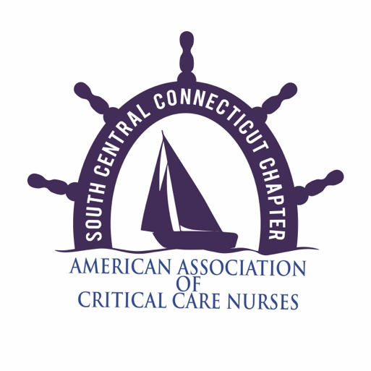

**This month please help us support**

**Yale New Haven Hospital’s Neonatal Intensive Care Unit Bereavement Team.**

**They support families through their hardest time, the loss of a little one.**

**Your donations will be used to create a little box of memories for these families to go home with.**

**What we are looking for:**

**Gift Card’s to Michaels’ Craft Store**

**The book *Something’s Happened* by Cathy Blanford**

**(Spanish and English editions)**

**Onesie’s aged preemie to 6 months (white or soft pastel colors)**

**Infant knit hats (white or soft pastel colors)**

**Travel sized tissues**

**Hand/ Foot mold keepsake impression kit**

**Monetary donations are also appreciated**