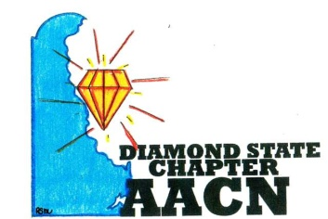 Est.2006 
“Shine Bright Like A Diamond”
Agenda January 9, 2018
- Welcome and recognition
- Introductions of any new members
- Recognition of newly certified or any other professional accomplishments of chapter members
- Reports
- Review of November minutes
- Treasurer report
- Old Business
- Education event Feb 23, 2018 @ The Duncan Center
  - Planning call: Jan 16 at 6pm
- Polos
- Circle of Excellence Chapter Award: Chapter Educational Programming, Honorable Mention
- President’s Award for Chapters: Due February 15, 2018
- Medtronic Dinner Meeting April 2018
- New Business
- Guided by Why January Recognition
- March Meeting: Certification Celebration
- Survey Member Needs:
  - Fund Raiser
  - Open House
- AACN Webinar: DOACs: Prescribing Guidelines & Clinical Implications
- Roundtable
Next meeting ? February 13th 6pm @ Bayhealth?

