
Northern Virginia Chapter
Northern VA ENA Meetings 2018
This list is subject to change. Locations will be finalized three weeks prior to the meeting date. We will be moving the NoVENA meetings around the area, so stay tuned for new locations, and get involved!
Jan 17, 2018 1:00p-3:00p -Location to be finalized in the next week- Registration will be up at that time, watch for email.
Feb 21, 2018 6:00-8:00-TBD
Mar 21, 2018 1:00p-3:00p-TBD
Apr 18, 2018 6:00p-8:00p-Child Abuse Topic
May 16 2018 1:00p-3:00p-TBD
Jun 20, 2018 6:00p-8:00p-Virtual meeting using software such as gotomeeting or zoom. Valid ENA membership will be required get access code.
July 18, 2018 6:00-8:00p-TBD
August 15, 2018 1:00-3:00-TBD
September 19, 2018 -6:00-8:00 TBD, National Re-cap, Election Planning
October 17, 2018 - 1:00-3:00-Domestic Violence topic
October 1st-Oct 25th 2018 Board of Directors Elections voting. All votes will have to be entered and board has to be selected by 10/31/18.
November 21, 2018 1:00-3:00 Virtual Meeting using software such as gotomeeting or zoom. Valid ENA membership will be required get access code.
Dec 19, 2018 - 6:00p-8:00p-End of year celebration for all the great things we’ve done for Emergency nurses everywhere.
Spread the word and watch for exciting things in 2018.
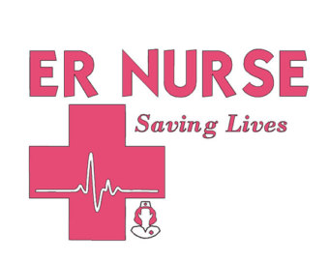
Please feel free to contact Stephanie Fitch with meeting location, suggestions or topics at Stephanie@fitch-family.org.

