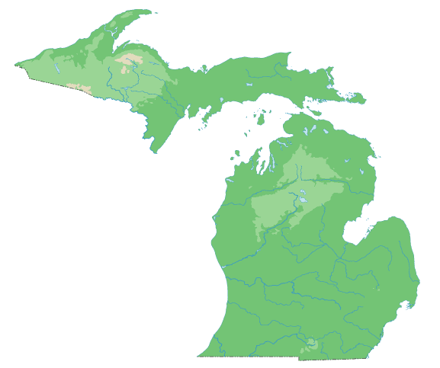

THE
MICHIGAN
ASSOCIATION
OF
REHABILITATION
NURSES

Presents:

“SAFETY IN REHABILITATION
– IT’S A TRIP”

APRIL 29th, 2025
7:00am – 4:15pm

EARN 6 NURSING CEUS FOR ATTENDING
COURSE OVERVIEW

Successful rehabilitation nursing encompasses the transfer of knowledge and accountability for all healthcare needs from healthcare professionals to the client, family, and significant others. This transfer must be done with a holistic approach, and safety should be a top priority in all aspects of care.

ABOUT THE SPEAKERS

Dr. Michael Majed Ajluni MD – Physiatrist at the Rehabilitation Institute of Michigan presenting “TBI Recovery After the Acute Phase”

Elizabeth Rudolph, JD, MSN, RN, PLNC – Attorney and CEO at JurexNurse.com presenting “Surefire Documentation”

Patricia A. Quigley PhD, MPH, APRN, CRRN, FAAN, FAANP, FARN – Nurse Consultant – presenting “New Directions in Fall Injury Prevention”

Tracey Connolly MSN, RN, AGCNS-BC, CRRN, WCC, FARN – Clinical Nurse Specialist at Rehabilitation Institute of Michigan - presenting “Neurogenic Bowel and Bladder: Helping Patients Go with the Flow”

Candace Dorsey MS – Empowerment Self Defense Program Manager at U of M Police Department’s Community Outreach Program presenting “Early Intervention and Personal Safety Strategies”

Michele Derheim MSN, RN, CNML – Clinical Nurse Director at Michigan Medicine – “Change Your Question – Change Your Life”

INTENDED AUDIENCE

Rehabilitation nursing is a philosophy of care that can be applied to any care setting, location, or patient population. This conference will be valuable to all nurses and other health care professionals including therapists working in hospitals, home care, case management, sub-acute, extended care, assisted living, or any other environments that provide restorative and custodial care to individuals with acute and chronic conditions.

CONTACT HOURS

This continuing education activity has been submitted to the Ohio Nurses Association, and accredited approver by the American Nurses Credentialing Center’s Commission on Accreditation (OBN-001-91) and was awarded 6 contact hours. It also was submitted to the Commission for Case Manager Certification for approval to provide Board Certified Case Managers with 6 clock hours.
To receive the 6 hours of continuing nursing education or case management clock hours you must attend the entire event and submit a completed evaluation form.
** There is no conflict of interest for anyone with the ability to control content for this activity. **

WORKING AND PLANNING COMMITTEE

President: Kimberly Wagenknecht BSN, RN, CRRN, CNML – Clinical Nursing Supervisor – Michigan Medicine

President Elect: Lisa Aaron-Laco RN, CRRN – Registered Nurse – Michigan Medicine

Secretary: Anne Smith MSN, NP-C, RN, CRRN – Retired Associate Director of Education – Comprehensive
Rehabilitation Consultants

Treasurer: Kimberly Wagenknecht BSN, RN, CRRN, CNML – Clinical Nursing Supervisor – Michigan Medicine

Directors:

Tracey Connolly MSN, RN, AGCNS-BC, CRRN, WCC, FARN – Clinical Nurse Specialist – Rehabilitation Institute
of Michigan

Patti Wisniewski RN, CRRN – Education Nurse Coordinator – Michigan Medicine

Andrea Dube RN, CRRN – Primary Nurse – Henry Ford - St. John

Tabatha Cronander RNP-C, CRRN – Lead Nurse Practitioner – Specialists in Rehab Medicine P.C.

REGISTRATION
Early Bird Registration Before March 31st, 2025: Registration after March 31st, 2025:
MI-ARN Member: $115.00 MI-ARN Member: $140.00
ARN Member: $135.00 ARN Member: $160.00
Non-Member: $150.00 Non-Member: $175.00
Full Time Nursing Student: $75.00 Full Time Nursing Student: $95.00
Retirees: $75.00 Retirees: $95.00

Deadline for Registration: April 11th, 2025

Refund Policy: Cancellation after April 11th, 2025 will be subject to a $25.00 administration fee.
Registrations are transferrable with prior notification.

Everyone has a different level of comfort. PLEASE DRESS IN LAYERS. Attendees must be present for the entire program and submit a completed evaluation form to obtain a contact hour certificate.

Electronic registration and payment via credit card are to be
made directly on the website.
https://miarn.nursingnetwork.com
If you have any questions regarding registration, please contact:
Kimberly Wagenknecht – President of MI-ARN – cell #: 734-391-9721

Conference Agenda

7:00 – 7:45am Registration / Continental Breakfast / Exhibitors

7:45 – 8:00am Welcome

8:00 – 9:00am Dr. Michael M. Ajluni – “TBI Recovery After the Acute Phase”

9:00 – 10:00am Elizabeth Rudolph – “Surefire Documentation”

10:00 – 10:30am Morning Break / Exhibitors

10:30 – 11:30am Pat Quigley – “New Directions in Fall Injury Prevention”

11:30 – 12:30pm Tracey Connolly - “Neurogenic Bowel & Bladder: Helping Patients Go
with the Flow”

12:30 – 1:30pm Lunch Break / Exhibitors

1:30 – 2:30pm Candace Dorsey – “Early Intervention and Personal Safety Strategies”

2:30 – 3:00pm Afternoon Break / Prize Drawings

3:00 – 4:00pm Michele Derheim – “Change you Question – Change Your Life”

4:00 – 4:15pm Closing / Evaluation

Michigan
Association
of
Rehabilitation
Nurses

Presents:

“REHABILITATION NURSING -
IT’S A TRIP”

APRIL 29th, 2025

Michigan Association of Rehabilitation Nurses
c/o 11875 Tipton Hwy.
Tipton, MI 49287
