**SAVE THE DATE!!!**

**Diamond State Chapter Symposium**

**Guided by Why: To Improve Patient Outcomes**

**Featuring Keynote Speaker-AACN President-Elect**

**Lisa Riggs, MSN, APRN-BC, CCRN-K**

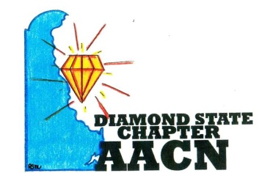

**Date: February 23, 2018**

**Time: 8am-3pm**

**Where: Duncan Center**

**500 Loockerman Street, Dover, DE 19904**

**“SHINE BRIGHT LIKE A DIAMOND”**