Guided by Why-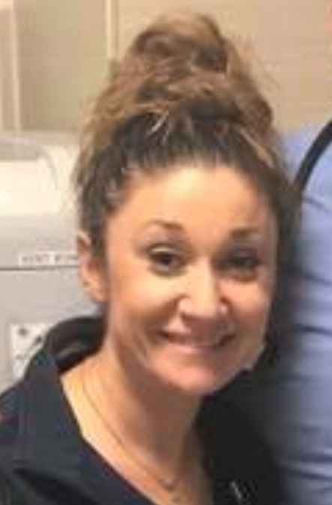

Amanda Latina, BSN, RN-BC

I began to write this excerpt and a code blue was called. Needless to say, I returned to my desk and I deleted everything I had previously written. It is hard to pin point a clear pivotal moment in my life when I decided, “I wanted to be a nurse,” but it is days like today that remind me of my “why.”

Throughout my 10 years in nursing I have witnessed life, death and everything in between. I have been in the Trauma field for my entire career and to say it has been extremely rewarding would be an understatement.

I have cared for physicians, lawyers, and prestigious political figures. I have also cared for prostitutes, pagans and prisoners, all who have given me such a different, yet invaluable outlook on life. Nursing has introduced me to a world I would have never seen, had it not been for choosing to be a nurse.

I have witnessed a Traumatic Brain Injured patient “wakeup” and call his mom on Mother’s Day morning to say, “I love you.” That was a mother’s day I will never forget. I experienced a 23 hour patient say to me, “you look like an angel,” and then quickly drift off into eternal rest. I can’t put into words what actually happened at that exact moment, but it was something that I will remember for the rest of my life. These moments define why I do what I do.

Although, we as nurses often hear, “you’ve been such a blessing to me,” for me it is the complete opposite. The invaluable encounters with complete strangers have been a blessing to me. Nursing is not a title to me, it is not my job nor is it my career; nursing is my vocation.