Experience Sound Therapy

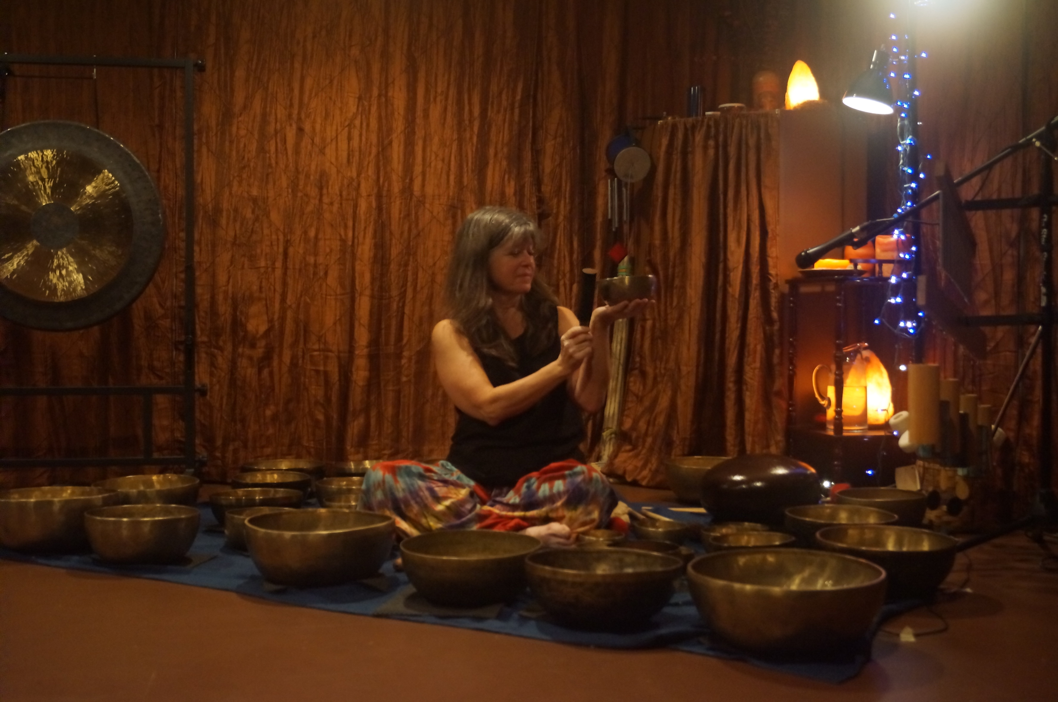EXPERINE

with Judy Rosen

Certified Sound Therapist

Saturday, January 20th

2:00 to 5:00 pm

**Sound Therapy is the intentional use of sound to create an environment which becomes a catalyst for healing in the physical, mental, or spiritual aspects of our being. Sound Therapy can be both a unique and complimentary approach to relaxing the body, quieting the central nervous system, stilling the mind and connecting to one’s own capacity to heal, and its use is becoming more widespread. Experience the benefits of Sound Therapy first hand and explore how you might incorporate sound into your personal and professional practice(s).**

**This will be a hands-on workshop taking place in a private sound studio. During the afternoon, you will learn about the benefits of Sound Therapy, be instructed in how to play Himalayan Singing Bowls and practice giving and receiving individual Sound Therapy via small groups. Then relax and enjoy a Musical Journey experience with time afterwards for personal and group processing.**

**During the small group work and the Musical Journey portion of the program, you will either be lying on a thick mat on the floor, or sitting on a cushion on the floor. Please dress in non-restrictive and comfortable clothing.**

**The instructor is Judy Rosen of Ancient Melodies, LLC. Judy has been working with sound as therapy for over 15 years, been a practicing Sound Therapist since 2012 and received certification from Shree Krishna Shahi, a renowned Himalayan singing bowl master teacher who she studied with in Kathmandu, Nepal.**

**Registration of a minimum of 12 participants is necessary by January 8th to ensure that this program takes place. In order for each individual to receive the maximum benefit, the number of participants will be kept to 18.**

**The location is in Maryland Heights and exact address and directions will be provided a week prior to the event.**

**For more information about Musical Journeying visit:**

<http://www.journeythroughancientsound.com>

Fee: Healing Touch Members $25 Non Members $35

Register via: <https://healingtouchstlouis.nursingnetwork.com/> (Preferred)

Or call Pat Dulle 314-322-4028 via phone or text