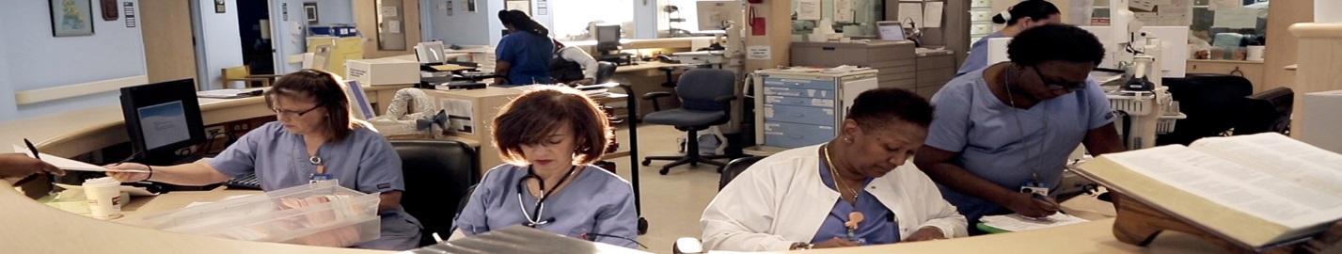

Please join us for a screening of DEFINING HOPE,
hosted by the Lawrence Community Palliative Care Advisory Council
&
Midwest HPNA
on Wednesday, November 1st at 7pm
at Regal Southwind Theater
3433 Iowa Street, Lawrence, KS
Join us for a networking dinner at 5:30 at
El Potro 3333 Iowa Street. Appetizers will be provided.

This screening is made possible thanks to the generous support of:
LCPCAC
Please email MidwestHPNA@gmail.com with questions.

For details regarding the film visit www.hope.film
View the trailer at https://vimeo.com/212253043

Nurses will receive 1.25 free contact hours for watching the film and completing the evaluation thanks to the generous support of Walden University.

