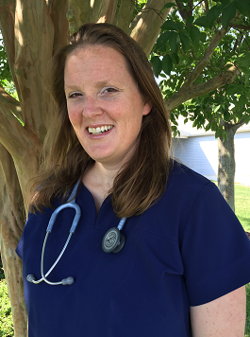**Guided by Why**

I love nursing and all the challenges that it brings. While a day in the life of the intensive care unit is never easy, there is never a day that I am not thankful for the opportunity to serve my community. I initially chose critical care nursing because it combines the science of medicine and the humanity of caring for another. While it is easy to get lost in the machinery and medications, one of my roles as a critical care nurse is to remind everyone on the care team that the patient we are caring for is more than the sum of their daily lab values and diagnostic tests.

I continue to choose critical care nursing because of the relationships I form with my patients and their family members. The look of relief that comes across a patient’s face when you take the time to listen to their feelings and explain all the complexities in a way they can understand reaffirms my commitment to the care of the critically ill patient. There is satisfaction in helping a patient to heal and there is honor in guiding a patient through their final moments.

Why I choose nursing is to be a steadfast advocate for my patients, especially when they are no longer able to advocate for themselves, to remind the team that just because we can does not always mean that we should, and to bring a small sense of comfort when people find themselves in their worst-case scenario. My “why” is because nursing challenges me to improve every day, to better myself, and to provide better care to my patients.

Jill Shore Petrone, BSN, RN, CCRN