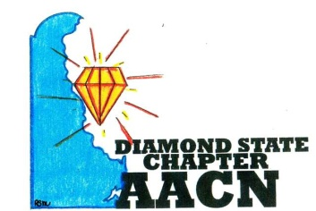 Est.2006 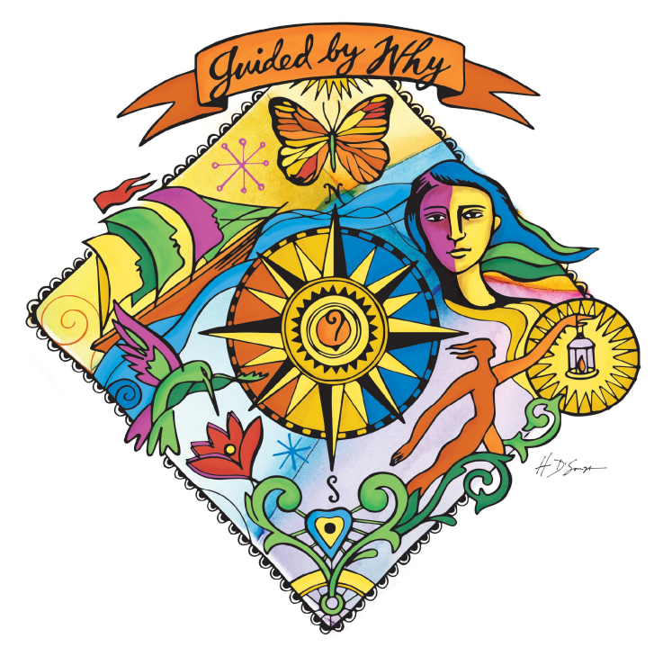
“Shine Bright Like A Diamond”
Agenda-October 10, 2017
- Welcome and recognition
- Introductions of any new members
- Recognition of newly certified or any other professional accomplishments of chapter members
- Reports
- Review of August minutes
- Treasurer report
- Old Business
- Ronald McDonald House- Sept 30th
- Education event Feb 2018- Planning call: Oct 19 at 6pm
- Buffalo Wild Wings Fundraiser- Monday Oct 23rd
- Polos
- Survey Member Needs
- Circle of Excellence Chapter Awards: Nov 1
- Student Mentoring Event April 2018
- New Business
- Guided by Why September Recognition: Jill Petrone
- Chapter Officer Descriptions
- DSC Special Project Nurses
- Calendar of Events
- December Meeting
- Roundtable
Next meeting November 14th 6pm @ Christiana

