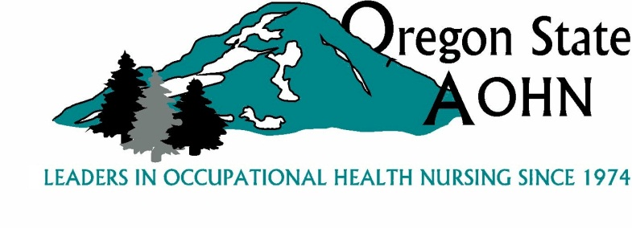

**2017 Fall General Meeting, Friday October 20, 2017**

**Legacy Woodburn Health Center 1475 Mt. Hood Avenue Woodburn, OR 97071**

**Hawthorn Room**

**AGENDA**

8:30-9:00 **Networking**

9:00 **Call to Order -** President Lisa Rodriguez

* Introductions
* Approval of Meeting minutes

**Treasurer’s Report -** Mary Pesch

Approval of 2017-2018 budget

**Report of the Standing Committees**

* **Bylaws, Rules and Procedures** - Lisa Rodriguez, Chair
* **Communications and Public Relations** - Marlin Kendall, Chair

Co-Chair Karin Drake

* **Finance** - Mary Pesch, Chair
* **Governmental Affairs** -Linda Meuleveld, Chair
* **Member Recognition and Awards** - Debbra Tatum, Chair
* **Membership** - Shelley Jones and Pat Bishop Co-Chair
* **Program, Education & Professional Standards** Chair Cindy Smith
* **Nominations** -, Meg Gustafson, Chair

**Old Business**

* Board vacancies - Nominations
* Scholarships and awards reminder

**New Business**

AAOHN Chapter/Membership news

10:00-10:15 **Announcements and adjourn**

10:15-10:30 **Break and networking**

10:30-11:45 **How to Create an Organizational Culture for** **Successful Aging, Dr. David Cadiz, Portland State University** Learn about the age diversity climate; the organizational factors that lead to a more positive age diversity climate; and the outcomes of a supportive age diversity climate

11:45-12:45 **Lunch and** **presentation by our lunch sponsor: Precision Diagnostics—Utilizing clinical drug testing analytics to identify trends in behavioral health,** **Jack Kain, PharmD, Clinical Toxicologist, Precision Diagnostics** Mental and substance use disorders (M/SUDs) can be correlated to a substantial amount of emergency department visits and inpatient hospital stays. In fact, it is estimated that 22.5 percent of adults (51.2 million) aged 18 years or older in the United States experienced one more M/SUDs in the past 12 months.In addition, 8.4 million U.S. adults suffered from co-occurring mental disorders and substance use disorders. For example, the occurrence of depression, anxiety or panic disorder is largely found in conjunction with a substance use disorder that is defined by alcohol abuse or illicit drug dependence. Clinical drug testing provides clinicians with a non-punitive clinical decision support tool to improve outcomes for patients who suffer from mental and substance use disorders. This presentation seeks to educate stakeholders on the utility of clinical drug testing, drug testing analytics and clinical decision support in behavioral health.

12:45 2:15 **Designing for Synergy—Building a Wellness Program with Safety in Mind, Leigh Manning, Sr. Safety Management Consultant, SAIF Corporation**

Where do you begin to develop a wellness effort that strengthens your existing injury prevention efforts rather than draws attention away from safety? How do you know what is right for your company? This session describes the steps in developing a wellness program and provides resources and tools to guide actions at each step, whether the attendee wants to begin a program, to validate she is on the right track with the existing program, or take the existing program to the next level.

2:15-2:30 **Break and networking**

2:30-3:30 **Teaching Occupational Health Nursing in Thailand, Dede Montgomery, MS, CIH, Oregon Institute of Occupational Health Sciences and Karin Drake, RN, BSN, COHN-S** Karin Drake, occupational health nurse, and Dede Montgomery, industrial hygienist, have teamed together during the past two years to support an international collaboration between Oregon Heath & Science University and Bangkok Dusit Medical Services. The OHSU-BDMS collaboration in occupational health efforts to establish a Center of Excellence in Occupational Health in Southeast Asia is a first of its kind effort to address occupational health standards, informatics, research, wellness and toxicology in Thailand. Karin and Dede will share their piece of this work which have included providing face-to-face training of occupational health nurses, occupational medical physicians, and other occupational health staff in Bangkok. During this informal presentation, gain an overview of the project and priorities, training goals and objectives, and participate in a short demonstration of hands-on practicums. Drake and Montgomery will conclude the discussion by sharing their perspectives on the similarities and differences between occupational health nursing and industrial hygiene in the U.S. and in Thailand.

*Attendance and lunch with no CEUs is $10. 4.5 CEUs will be available. Cost is $10 per CEU, $45.00 total. If you are purchasing CEUs, the attendance/lunch fee will be waived.

RSVP for lunch by October 16th to Cindy Smith at cinsmi@saif.com