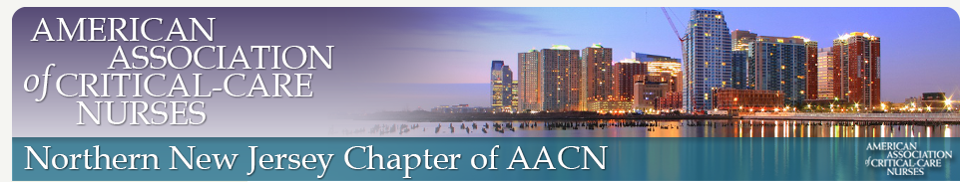



IT’S TIME TO RENEW YOUR MEMBERSHIP!

NOT AREADY A MEMBER? *JOIN TODAY*!

* Chapters provide quality education
* Opportunities for members to become known by their peers, participate in their communities, and interact with local and national leaders- NETWORKING!
* Develop and build on leadership skills
* Excellent forum for exchange of ideas and sharing practice with critical care nurses from your area.

**NNJ-AACN is now Paperless!!!**

* Go to our website nnjaacn.nursingnetwork.com
* Click on membership/join now
* Join or renew
* Once you receive your confirmation email print out your card

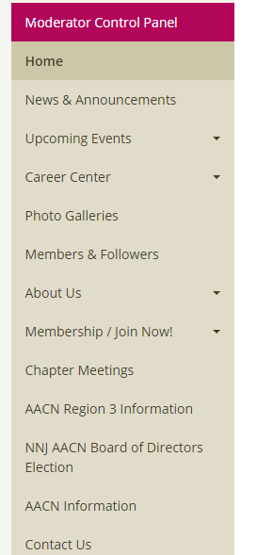

**SAVE THE DATE**

**Options in Critical Care** **2018 :April 19th and April 20th**

*Watch for the early bird special reduced price for *Members Only* so Join Today!*

Membership in the NNJ-AACN requires that you become a member of National AACN ([*www.aacn.org*](http://www.aacn.org/)*- Join Now*) –

AACN- Cost- Active – 1 year - $78

**NNJ- AACN - $30-1 year**

Becoming involved in NNJ- AACN: Board meetings are held on the first Wednesday of each month at 6pm. September, November, January, March, May at Chilton Medical Center; October, December, February, April and June at Morristown Medical Center. Meetings are open to all NNJ-AACN members. Advance notification of attendance appreciated.