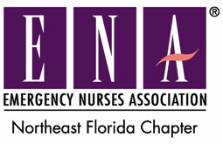
Next meeting:
Thursday, October 12, 2017
7:00-8:30 pm
Geriatric ED Visits and The Relevance of Home Care
Speaker: Kristi O'Neal, Certified Senior Advisor Client Care Liaison
Making the Invisible Visible: ER Nursing Care of the Crohn's and Ulcerative Colitis Patient Population
Speaker: Janet Jesiolowski, BSN RN-BC CSRN CFN SCRN CMSRN

Location: St Vincent’s Southside
4201 Belfort Rd, Jacksonville, FL
Bryan Auditorium- Take employee entrance to the left of the large glass
entrance to the Family Birth Center
Parking: Take left at main entrance and head past ER to Employee parking lot F. You may park anywhere in this lot.

Dinner included, you must RSVP by 10am Wednesday October 11th

RSVP: https://nefloridaena.nursingnetwork.com/nursing-events/69681-october-chapter-meeting#!info

