
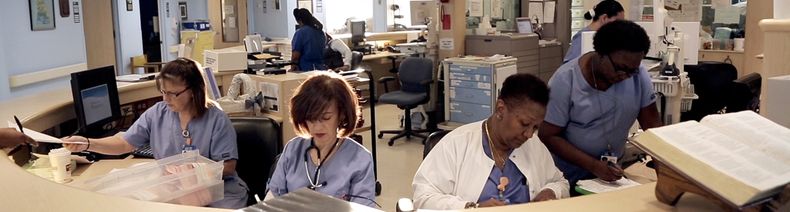
Please join us for a screening of DEFINING HOPE hosted by:

Central Alabama Hospice & Palliative Nurses Association

Wednesday, November 1st at 7pm at

Regal Trussville Stadium 16
5895 Trussville Crossings Parkway Birmingham, AL 35235

This screening is made possible thanks to the generous support of:

Alabama Hospice and Palliative Care Organization
Alacare Home Health and Hospice
Comfort Care Hospice
Samford University Health Sciences Center for Faith and Health
VA Medical Center, Birmingham

Please email hpnaofcentralalabama@gmail.com with questions.

Find local ticketing link, watch the trailer, and learn more at www.hope.film

Nurses will receive 1.25 free contact hours for watching the film and completing the evaluation thanks to the generous support of Walden University.

