SCAOHN Spring Conference 2023

It’s a Jungle Out There

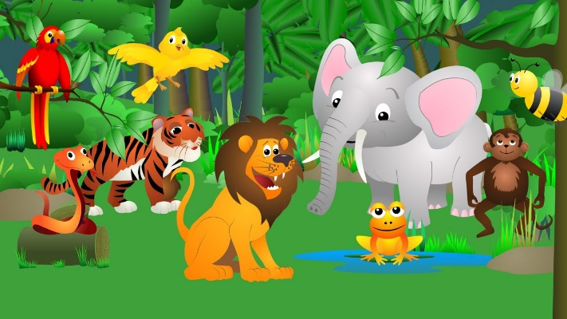

May 5, 2023
Riverbanks Zoo & Botanical Gardens, West Columbia, SC

Friday, May 5, 2023

8:00 – 8:20 am Registration & Networking Breakfast

8:20 – 8:30 am Welcome

8:30 – 9:30 am Don’t “Feed” the Animals: Substance Abuse Update
Hailey Kanipe, MPH, CPS, ICPS, Prevention Specialist, LRADAC
Ashley Bodiford, Director of Prevention, LRADAC

9:30 – 9:35 am Brain Break

9:35 – 10:35am Take a Walk on the Wild Side: Impairment Simulation
James G. Miller, Master Trooper, SCDPS Highway Patrol

10:35– 10:50 am Morning Break

10:50 – 11:50 am The Elephant in the Room: Part 1 – Reasonable Suspicion Policy
Jonathan Lane, Attorney, MGC Law

11:50 – 12:50 pm Lunch

12:50 – 1:50 pm The Elephant in the Room: Part 2 – HIPAA in the Workplace
Jonathan Lane, Attorney, MGC Law

1:50 – 1:55 pm Brain Break

1:55 – 2:55 pm Don’t Stick Your Head in the Sand When it Comes to Mental Health
Dr. Wesley Boose, MD, MPH, Lexington Medical Center

2:55 – 3:10 pm Afternoon Break

3:10 – 4:50 pm Site Hazards are Everywhere (Even at the Zoo)
Ashley Atchley, RN, Milliken Chemical

4:50 – 5:05 pm Wrap-Up & Evaluations



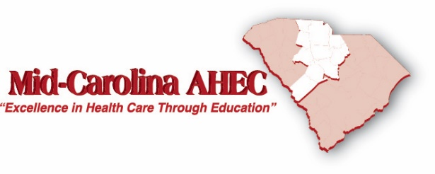
6.5 clock hours of CEU’s applied for from Mid-Carolina AHEC

