Donations for Hurricane Harvey | - Faith in action  - •  - BVAACN
Please consider helping in the  following ways:  Contribute toiletries  FIAI can accept the following items, placed in 1-gallon sealable/Ziploc plastic bags:  - Soap  - Lotion  - Shampoo  - Deodorant  - Washcloth  - Comb/brush  - Facial tissue  - Shaving cream/razor  - Toothbrush/toothpaste  - Feminine hygiene products  Contribute first aid kits  Purchased (for up to $10 each) at grocery and drug stores.  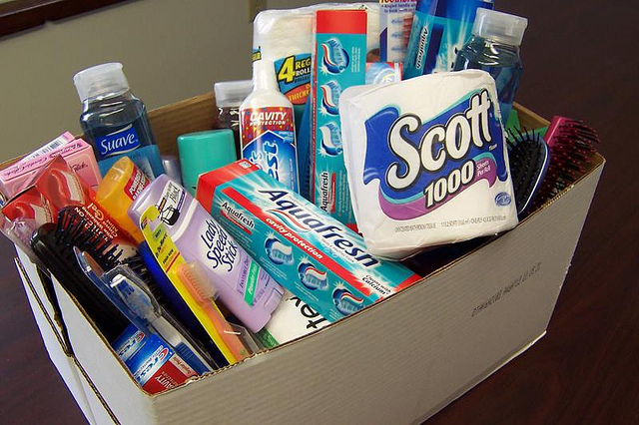 | 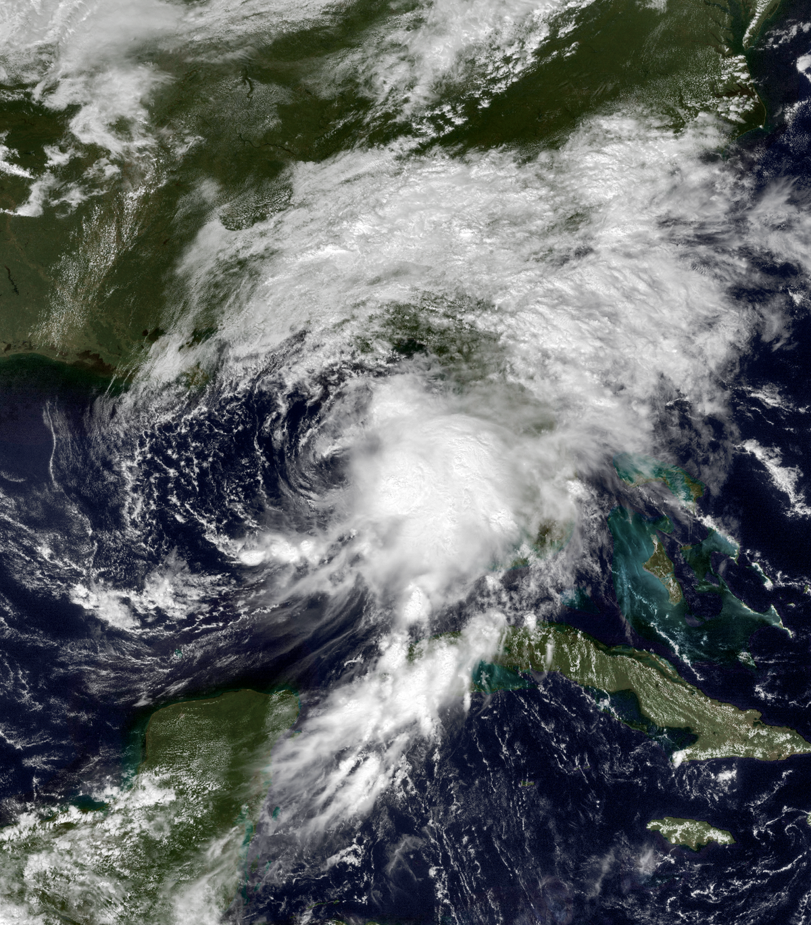  Since 2009, Faith in Action Initiatives (FIAI) has provided relief in a variety of disaster situations everywhere from Oklahoma to Nepal. This time, help is needed close to home due to hurricane Harvey.  FIAI is:  - Monitoring the needs closely through Red Cross, Salvation Army, and Texas Baptist Men  - Sending disaster relief kits (hygiene and first aid)  Donations will be collected and delivered to Front Entrance of BSWMC—College Station.

