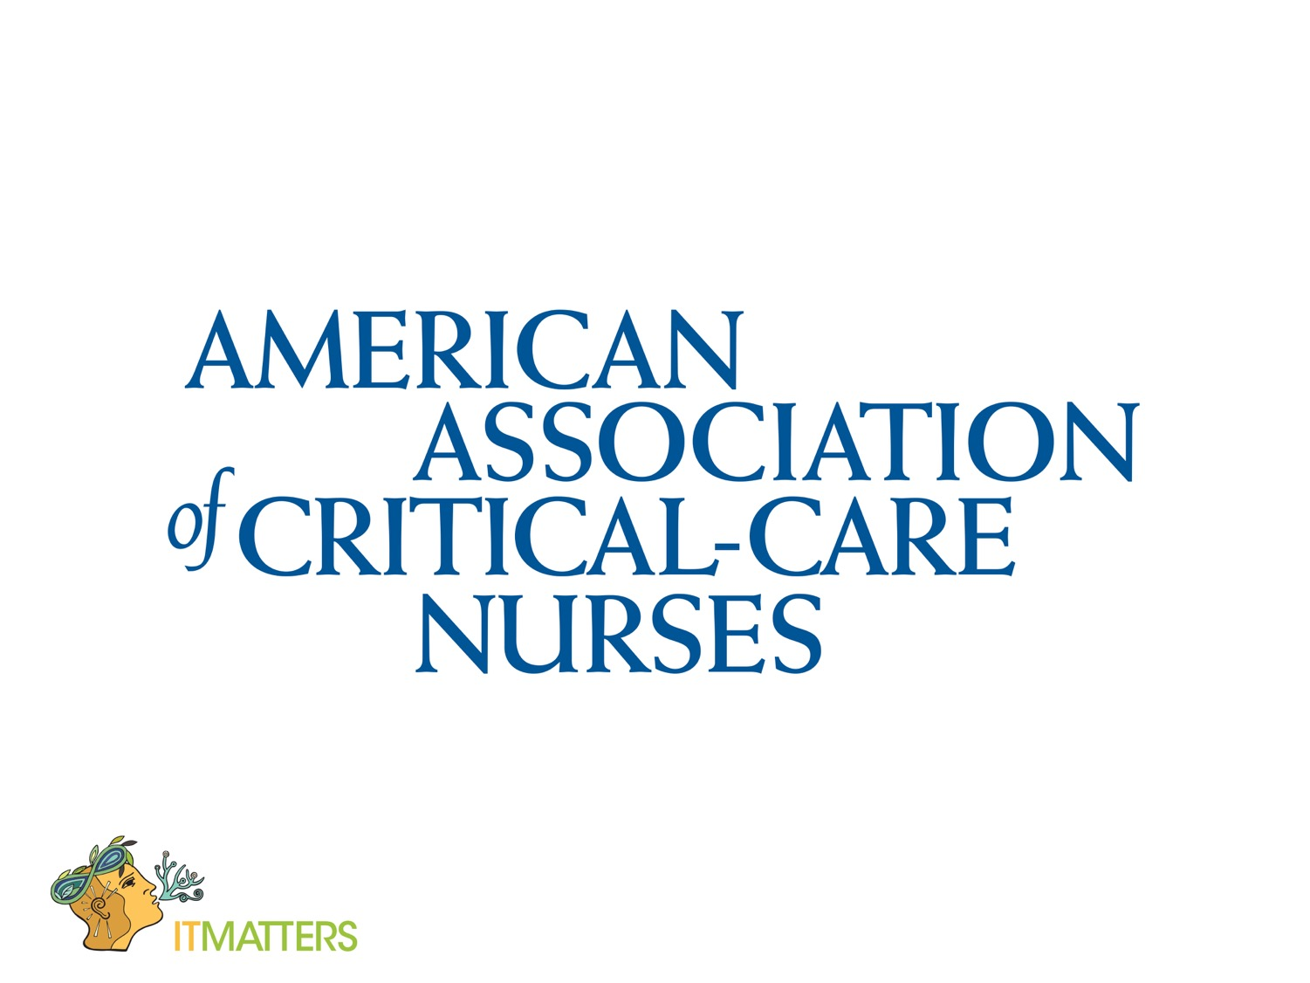

Critical Care Bowl

2017 Game Rules

1. Hospitals & organizations may submit more than one team but the teams

may not have the same team member(s) on more than one team.

2. Teams may be comprised of up to five persons plus an alternate.

3. Team members are to be bedside nurses. Managers, advanced practice nurses, cns, educators are not allowed to participate. Patient care coordinators and clinical facilitators (assistant nurse managers) may compete as long as they are not masters prepared rn’s.

4. The tournament is single elimination.

5. Points will be deducted for incorrect answers.

6. Two team names will be drawn from a hat to determine who will compete for each round.

7. A quarter toss will determine which team selects the first category and point value question for each round.

8. Each Team may buzz in while the question is being read and then has 30 seconds to answer the question. The question will stop being read as soon as the buzzer sounds.

9. In the event that neither team buzzes in, 30 seconds will expire and the answer will be revealed before moving to the next category & question.

10. Team members may confer after buzzing in but must begin their answer before 30 seconds has expired.

11. Any team member may answer the question.

12. If a team answers incorrectly, the opposing team will have 30 seconds to answer the question or pass after hearing the question in its entirety.

13. The team with the last correct answer chooses the next category and point value question.

14. **The judge panel has the final say on all answers and no challenge is allowed.**

15. Both teams will participate in the final bonus question as long as they have a positive point balance. In the event a team has a negative point balance, they are ineligible to participate and the opposing team will advance to the next round.

16. Each team will be given the category for the bonus question and will then have 15 seconds to wager points up to the total they have accumulated.

17. Teams will have 30 seconds to answer the bonus question and the team with the most points at the end will advance to the next round or be declared the winner of the competition.

18.Any item(s) is subject to change at the cic aacn board’s discretion.

Central Indiana Chapter of AACN

CIC-AACN was formed in 1972. Our chapter is one of over 230 local chapters of the National AACN organization. We host an annual Critical Care Bowl Competition every fall. This year’s CCB is September 14 Location: IU Health

Methodist Hospital.

Registration at 5:30

Competition at 6:00

Welcome to the Central Indiana Chapter of !

the American Association of Critical Care Nurses (CIC-AACN). Our chapter is one of over 230 local chapters of the National AACN and is in Region 9 (IN and OH). CIC-AACN was formed in 1972 and has grown to over 100 members. We are a not-for-profit, educational organization dedicated to the professional and educational growth of our members.!