**ANNUAL CONFERENCE**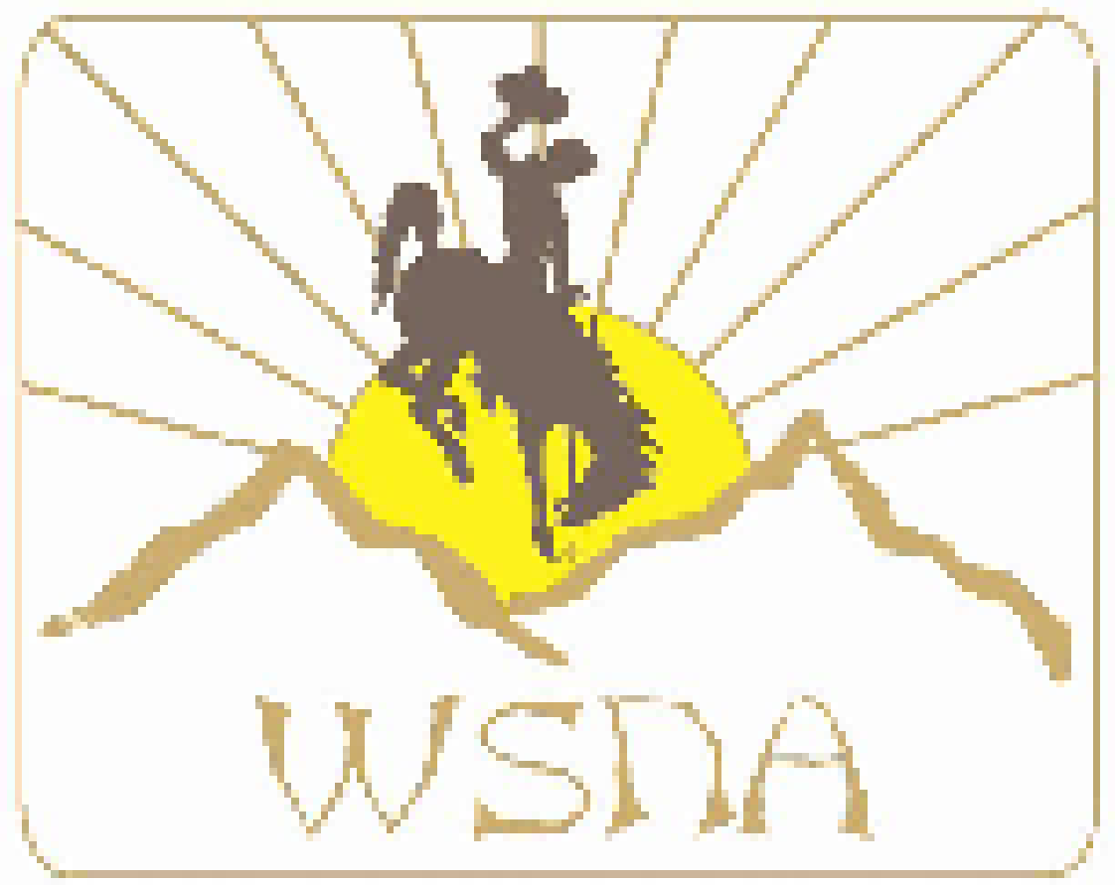

**WYOMING SCHOOL NURSES’ ASSOCIATION**

# OCTOBER 6 & 7, 2017

###### RADISSON INN, CHEYENNE, WYOMING

## FRIDAY, OCTOBER 6, 2017

**Noon- 12:30 PM Registration and check-in**

**12:30 – 12:45 Welcome and housekeeping**

**1:00 – 2:30 It’s not getting any better! How schools help with persistent post-concussion symptoms Dr. David Baker, Children’s Hospital Colorado**

**2:30 – 2:45 Break and afternoon snack**

**2:45 – 3:15 What’s Happening at NASN that affects Wyoming Students**

**Alicen Hardy, Wyoming NASN Director**

**3:15 - 3:30 How does national certification help you become a better school nurse?**

**Teresa Wright**

**3:30 - 4:00 What does WY data from Step Up and Be Counted tell us about the our students?**  **Chris Bartholomew**

**4:00 - 4:30 How can we have a strong voice at NASN?**

**Janet Farmer**

**Discussion regarding proposed guidelines for the Wyoming NASN Director**

**4:30 - 6:00 So you have a concussion. What’s next?**

**Dr. Aaron Powell, Children’s Hospital Colorado**

**6:00 Dinner and evening on your own**

## SATURDAY, OCTOBER 7, 2017

**8:00 – 8:30 AM Registration - Continental breakfast provided**

**8:30 Welcome and housekeeping**

**8:30 - 9:45 The Culture of Concussion Reporting in Youth Athletes**

**Dr. Alissa Wicklund, Orthopedic Center of the Rockies**

**10:00 – 11:30 What’s happening in WY school nursing and how does WSNA support better**

**student health?**

**WSNA Treasurer’s report - Karen Patton**

**Proposed NASN Director guidelines**

**Election of officers and director**

**Awards presentation**

**11:30 – 12:30 Lunch (provided)**

**12:30 – 2:00 What’s New at Wyoming Department of Health**

**Immunizations - Jude Alden**

**2:00 Closing and Adjourn until 2018!**

**CONTINUING EDUCATION PROGRAM: 0.5 PTSB CREDITS HAVE BEEN APPLIED FOR .**

**ACCOMMODATIONS**

**Radisson Hotel will be the base hotel for the meeting and the participants**

**Radisson Hotel**

**200 W. Fox Farm Road www.Radisson.com/cheyennewy**

**Cheyenne, Wyoming 82007 307-638-4466**

**\*Meeting participants are being offered a room rate of $89.00**

**\*Mention that you are attending the WSNA meeting.**

**\*TO GET SPECIAL RATE YOU MUST CONFIRM ROOM BY SEPTEMBER 17, 2017**

## WSNA Fall Conference Registration Form (Complete information and return with payment)

### Name______________________________ Address__________________________

**School District ___________________________________________________________**

**Assigned Schools ________________________________________________________**

**School Phone #__________________ City_________________ State__________________**

**Registration & Payment Enclosed:**

**____ WSNA member $75.00**

**____ Non-member $ 100.00**

**Payment type (please check):**

**____ Personal Check**

**____ Purchase order/check from district**

**Registration must be received by SEPTEMBER 20, 2017 to order food for the event.**

**PLEASE DETACH AND SUBMIT REGISTRATION FORM AND FEES TO:**

#### Karen Patton, P.O. Box 478, Hanna, WY 82327-0478

##### MAKE CHECKS/PURCHASE ORDERS PAYABLE TO:

##### WYOMING SCHOOL NURSES ASSOCIATION

#### Cancellation Policy:

#### Full refund if cancelled before September 15, 2017.

#### $20 (food cost) will be charged if cancellation occurs after September 26, 2017.

**Questions about Conference?**

**Janet Farmer (**[**janet.farmer@laramie1.org**](mailto:janet.farmer@laramie1.org) **) or Brenda Wrede (**[**Brenda.wrede@laramie1.org**](mailto:Brenda.wrede@laramie1.org) **)**