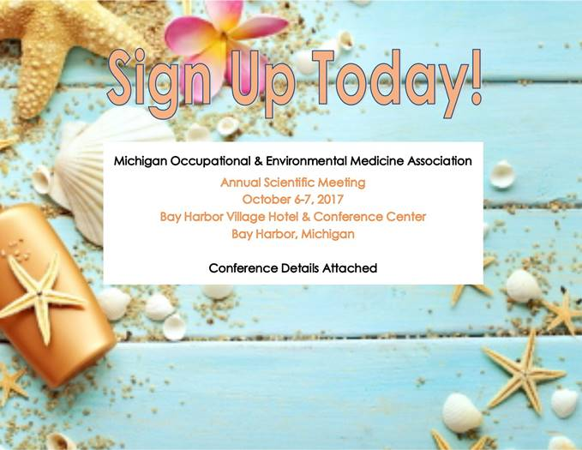

**Make you room reservation prior to the September 1st deadline by**

**calling (888) 229-4272, the dedicated room block phone-line, *TODAY*!**