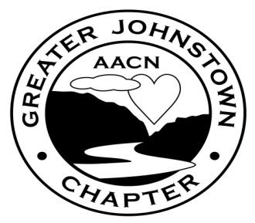

Greater Johnstown Chapter

American Association of Critical-Care Nurses
Board of Directors and Chapter

Meeting Agenda
Date __July 18th 2017____

5:00 | Meeting Called to Order – __Rizzos_______ (Location) | S. Rhoades
 | Call for approval of __June/2017____________ (month/year) meeting minutes | S. Dunn
 | Review of Chapter Good Standing Grid and upcoming due dates | A. Alcantara
 | 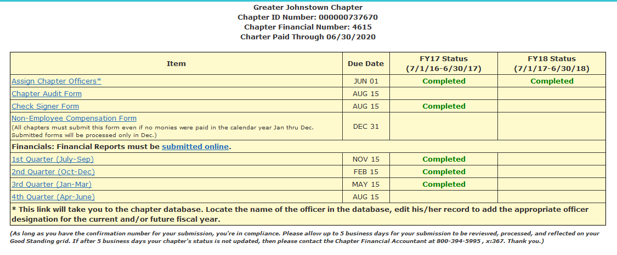
 | Membership & Engagement Chairperson Report | S. Morrison
- Membership update:
- Welcome new members: _______________________________________
- Membership count is ____ . Of these:
_____ need renewed nationally or locally with the chapter, reminder letters were emailed. _____ will be removed from the National Database as they have been inactive either nationally or locally with the chapter for a period of 6 months or more (in accordance with chapter bylaws).
Please bring 15$ at the July meeting for local dues if you haven’t paid so far!!
- Local dues of $15 may be paid by check at meetings or by charge via NN.
- Vouchers for national membership remain available through the 6A/R ICU educator’s office or at the meeting.
 | Treasury Report | S. Oldham/  C. Romani
- Financial Reporting
  - The 4th quarter report needs submitted before the 8/15 due date.
- Current Account Balance: $____________.
- Outstanding checks, upcoming expenses ___________________________.

 | Directors/Auditors Report | K. Bracken/ M. Murphy/ D. O'Roark/ K. Valkovci/ H. Vitko
 | - Auditor duties – F/U audit
 | Scholarship & Merit Chairperson report | D. Dubay
- FY 16-17 merit forms were due July 10th.
  - Any questions please speak to Darlene in person or via email ddubay@conemaugh.org

- Call for volunteers to meet to revise current merit guidelines and forms. Voted to switch merit guidelines for 2018-2019 to a points system which needs further development.

 | Education Coordinator and Programming Chairperson Reports | C. Schilling/  N. Custer
- Approved FY 17-18 calendar, marketing (magnets, flyers, email, NN)
- Upcoming meetings: August: Kristie Murray, September: Rick Kutz, awaiting reply from Dr. Golden for confirmation of dates.
- Call for topics or sponsors for upcoming meetings.
- PCCN/CCRN review-online option available since no current plans to host a PCCN/CRRN review.

 | GJC Presents… Region 3 Collaborative ‘17 | D. O’Roark/  D. Drahnak
- Registration/Fees
- Save the Date/Brochures
- Vendor updates

 | Certification & Recognition Chairperson | C. Trimeloni
- Recognizing newly certified members: ______________________________________
- Recognizing professional accomplishments: __________________________________
- Recognizing personal/family events: ________________________________________
- Sharing of any personal losses: _____________________________________________
- Certification plans FY 17-18:

 | Mentoring/Nominating Chairperson Report | F. Watson
 | Board contracts-3 outstanding, returned your copy tonight, archived electronically
 | Community Chairperson | C. Schreyer
 | - Upcoming plans:
 | Media Chairperson | D. Drahnak
- Nursing Network (NN)- Recent Posts, Registration
- Facebook
 | Open Forum | S. Rhoades
 | Meeting debrief | K. Gorman
 | Dinner orders/buffet lines
 | Presentation:
 | Thank you to speaker,  - Evaluations will be completed prior to receipt of meeting CE/CERP. | C. Schilling
 | Adjournment  ~ Scrap booking- GJCs Reasons Why….  ~Cake | S. Rhoades
Items dispersed and/or available upon request:
- Board/Chapter and Educational Meetings sign-in-sheets
- Chapter application/rejoining forms and National member vouchers
- Speaker/event evaluation forms

