My WHY!
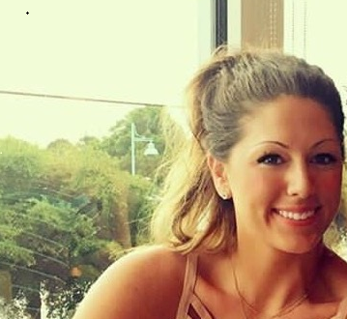
I decided to become a Registered Nurse because I always knew I wanted to make a difference in someone’s life. Volunteering in a hospital during high school, I was able to see the direct impact a nurse’s care had on each patient, and I knew that is what I wanted to do. After I graduated nursing school, I accepted a position on a Pulmonary Step-down unit where I gained amazing critical thinking skills and learned so much about pulmonary critical care. I loved the challenging patient population and credit so much of my knowledge to that amazing unit. After a few years, I decided to try a new area in the PACU. In this patient care setting, I developed new skills and am extremely grateful for my time spent there, but knew I wanted more. I missed following the patients day by day. I missed talking with patients and families, and making a difference to people who will remember me. I recently accepted a position in the Surgical Critical Care Complex at Christiana Hospital as the Assistant Nurse Manager. In this role not only do I get to work with a challenging patient population; I am able to work side by side with an elite group of nurses and leadership team.
I give so much credit to all of the people I have met along my nursing journey. I have created friendships with people that will last a lifetime. I am forever grateful to my peers and mentors that have encouraged me to follow my dreams. I couldn’t be more proud to be a critical care nurse. “We don’t just see the rollercoaster our patients are on, but we ride it with them.”
Erica Patosky, MSN, RN, PCCN

