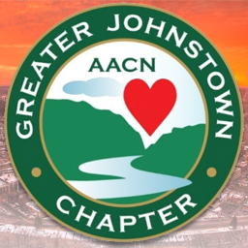

Dear GJC members, July 4th, 2017

I would like to thank each and everyone of you for your commitment to the nursing profession by being involved in our local chapter of AACN. Without your time and dedication our chapter would not be possible. It is with great excitement that we celebrate our 10th anniversary as a chapter this year!!! GJC is committed to providing education and networking opportunities for critical care and acute care nurses in the Johnstown area. This coming year I would like to recognize all our dedicated chapter volunteers who are committed to a culture of professional excellence and growth. I would also like to encourage new members to become more active in the chapter.
Chris Schulman, the national 2017-2018 AACN president introduced her theme “Guided by Why” at NTI in Houston. In her presentation speech, Chris explains that children question everything and the drive to question what is surrounding us is something that gets lost as we age. She encourages us to reconnect with the “Why” for them, whether it be personally or professionally. Another thing that touched me this year at NTI was a motivational speaker that said, “you are a direct reflection of the top 5 people you spend time with”. So think about the people you value in your life, think about why you became a nurse, think about why you continue to choose nursing and let that guide you throughout this coming year.

“Why is really our professional and personal compass. When we reconnect with why, we reaffirm our core purpose and have a guiding beacon for what we can—what we must—do to ensure that every patient gets the excellent care they deserve, and that every nurse has the tools and skills they need to provide that care.” ~ Chris Schulman NTI 2017

At our birthday celebration on July 18th please come with some ideas with what inspires you either personally or professionally so we can put a GJC “Why” scrapbook together!!

Sincerely, Stephanie Rhoades

