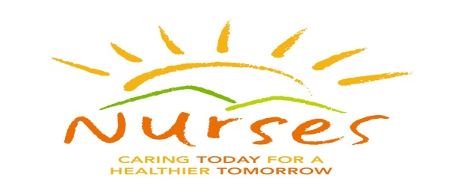
SAVE THE DATE
Northern NJ Developmental Disabilities Nurses Association Conference
Back to the Basics
Core Concepts of I/DD Nursing

September 29, 2017
Malcomb Forbes Auditorium
Morristown Medical Center
Morristown NJ
The Northern NJ Developmental Disabilities Nurses Association is the professional nurses association for nurses who provide health support to individuals with intellectual and developmental disabilities
CEU’s will be available
Visit our website https://njddna.nursingnetwork.com and Like us on Facebook
Questions? Email: caudibert@matheny.org
Call: 908-458-0047

