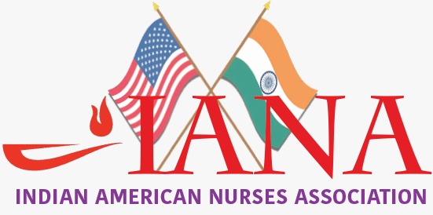

By: Suja Thomas, MSN.Ed., RN ( President)

The mission of Indian American Nurses’ Association of Albany, New York (IANA-A) is to serve as a professional body representing all registered nurses and nursing students of Indian origin and heritage in the state of New York, USA. This is a nonprofit professional/charitable corporation that collaborate with other community organizations to provide free health fairs, health educations and health screening programs that benefits the society and community at large. We believe in honesty and integrity, mutual respect, trust, quality, and teamwork. We strive for excellence in every aspect to achieve the goals of the association.

|  |
| --- |
| C:\Users\Suja Thomas\AppData\Local\Microsoft\Windows\INetCache\Content.Word\DSC02413.jpg |

**IANA-A Inauguration ceremony**

Inaugural Ceremony of Indian American Nurses Association was conducted on October 8th, 2016 from 11am to 6pm at Christ Our Light Church hall, 1 Maria Drive, Albany. This event was attended by 100 plus people. The Chief Guests were Congressman Paul Tonko, Honorable Dr.Aney Paul, Rockland County legislature, and Sara Gabriel, president of NAINA. The website go live was inaugurated by Congressman Tonko. There were many prominent community and health care leaders that were present and addressed the gathering during this event.

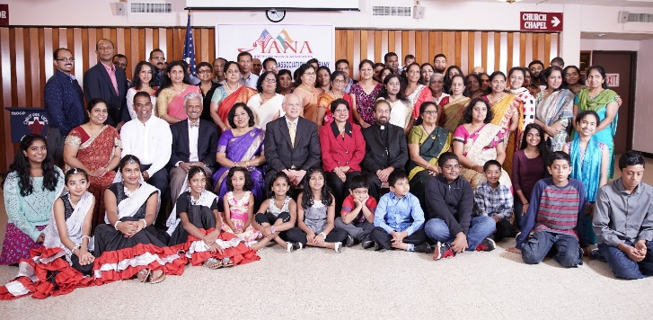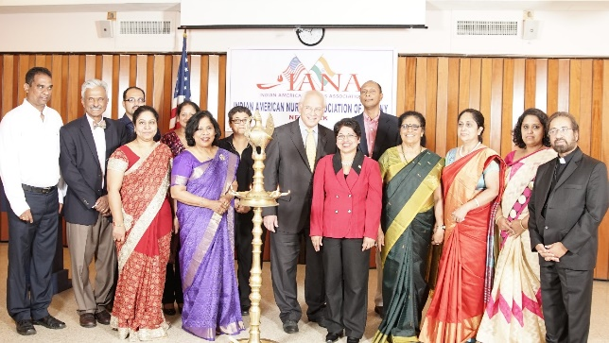

Dr. Romero did cancer screening health talk. The president gave the inaugural speech explaining the importance of having a professional organization in Albany. Sapna Mathai did the vote of thanks. The program ended with delicious dinner & was a grand success.

**Executive committee 2017**: Suja Thomas – President, Donnie Mathew- Vice President / webmaster, Sapna Mathai -Secretary, Rachana Mathew - Joint Secretary, Remani Thomas – Treasurer, & Santhamma Nair - Joint Treasurer. Chair Membership /Talent Management committee: Anie Kurian

Elsamma Mathew & Rachel Swami - Committee members

Chairperson of the Professional/education committee: Kasthuri Sivan

IANA-A Committee Members: Rajkumar ArulSelvam, Bindu Joseph, Priya Mathai, Kala Nair and Soosamma Mathew.

**IANA-A in Action**

Indian American Nurses have been active in the community to benefit the community in various ways. Family and Friend CPR (AHA)course was organized to accommodate 40 participants. This was conducted at Albany memorial Conklin Conference Room from 8:30 am to 12:30pm. This session prepared them to learn more about health and how to save lives in an emergency with infants, children, and adults. They also recognized the fact that minutes counts when it comes to a life and death situations. This was a grant success.

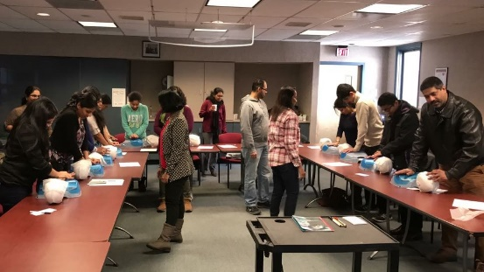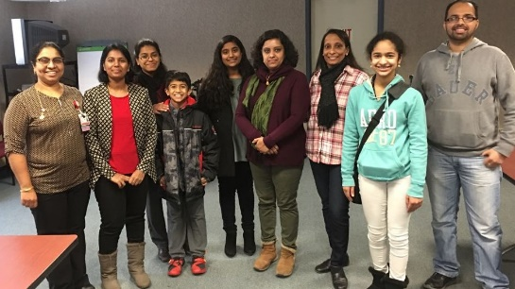

**Mother’s Day Celebration with CDMA**

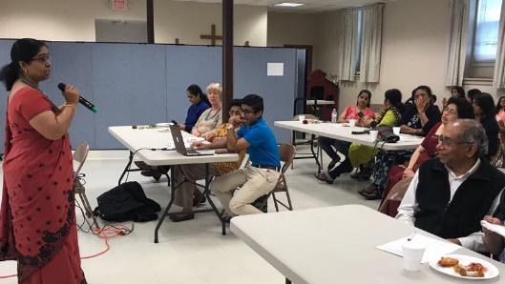Recently IANA joined hands with CDMA for the Mother’s Day Event by doing free blood pressure drive and education and counselling for people with high blood pressures and prevention of heart diseases. A health talk on osteoporosis and its prevention was conducted by the president of IANA-A.

This session was a revelation for many mothers understanding the importance of bone health and mother’s health for a better family and better community.

Our upcoming event will be IANA-A Annual Picnic that will be held on August 12th from 11am to 4pm at Tawasentha park, 188 State route 146, Altamont NY 12009. I like to conclude by thanking IANA-A team, our volunteers and community for their support and cooperation for making our efforts a grant success by your participation and feedback.

***************************************************************************