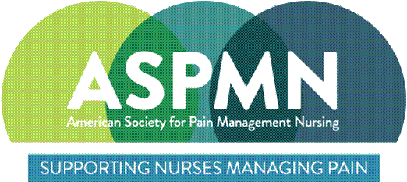 | ASPMN Pacific Northwest Chapter  CE Program and Chapter meeting  Meeting Agenda  Date/Time: April 8, 2020: 630pm – 830pm Pacific  Location: Zoom
Facilitator: Holly Watson |  | Agenda: Holly Watson  Note Taker: Diana Rae
Meeting Attendees (enter below):

For publishing minutes, copy this check mark to denote present attendees:
For those who indicated absence prior to meeting date, mark with “E” for Excused.
Purpose: This is a CE program and chapter meeting.
AGENDA
Topic |  |  | Time | Owner / Presenter
- Welcome, introductions, and approval of chapter meeting minutes |  |  | 15 min | Holly
- CE program: Rational Acute Pain Management in Opioid Tolerant Patients presented by Robert Montgomery, DNP, RN-BC, ACNS-BC |  |  | 75 min | Robert Montgomery
- Chapter meeting: |  |  | 30 min | Holly/all

# | Action Item | Owner | Due Date | Status

