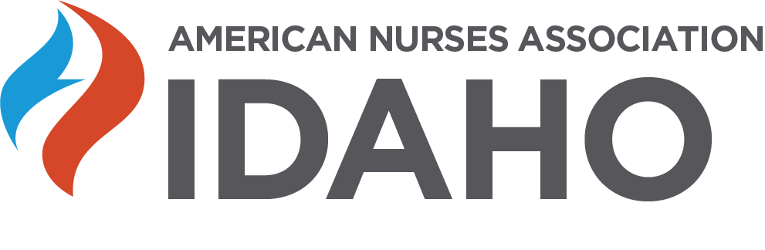I
LEGLISATIVE CONFERENCE 2020
Thursday, February 20, 2020
1 – 4:30 PM
Red Lion Boise Downtowner Hotel
1800 Fairview Avenue, Boise, Idaho
Agenda
1245-1:00—Welcome –Claudia Miewald, DNP, APRN-CNS & Anna Rostock, MBA, RN (Legislative chairs of NLI and ANA-Idaho)
1:00-1:30— Current Issues Discussed at the Idaho Legislature-- Mike McGrane, MSN, RN, & Benn Brocksome, Lobbyists for NLI and ANAI
1:30-2:00-- Medicaid Expansion in Idaho-- Logan Dennis, Policy Specialist, Idaho Voices for Children
2:00-2:30—30 minute dessert break
2:30-4:00---- HOT TOPICS IN IDAHO—Panel (moderator Margaret Henbest)
- Opioids in Idaho & the Idaho Office of Drug Policy—Melinda Smyser, Administrator
- How the 2020 census Impacts nursing --Juanita Risch, Regional Census Specialist
- Workplace Violence and Mental Health Exemptions—Rep. Lauren Necochea
- Honoring Choices Idaho –
4:00-4:30—Education issues of faculty supply, faculty salaries, clinical experience, new schools coming to Idaho—Krista Harwick, DNP, APRN-CNP, Representative of the Council of Nursing Education Leadership.
TOTAL 3.0 CNE APPROVED

