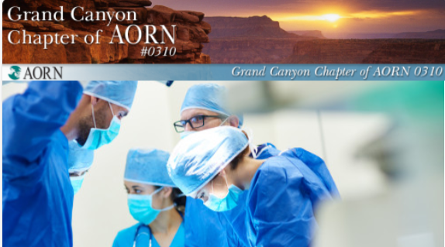
Fall Conference Agenda

Friday November 15, 2019
6:00pm-9pm | Pre-Fall Conference Social

Saturday November 16, 2019
7:00am-8am | Registration, Breakfast, Vendor Fair
8am-9am | Opening Introduction  Presentation: Reduce the Risk of Contamination on the Surgical Back Table- Nick Elliot-Tidi Products
9am-10am | Presentation: The Use of Robotics in Joint Replacement Surgery- Dr. Edward Petrow, DO
10am-10:30am | Break Vendor Fair
10:30am-11:30am | Chapter Business meeting
11:30am-12:30pm | Lunch Vendor Fair
12:30pm-1:30pm | Presentation: Early Experience with Robotic-Assisted Lumbar Instrumented Fusions- Dr. Richard Chua, MD
1:30pm-2:30pm | Presentation: Transcatheter or Surgical Aortic Valve Replacement in Low-Risk Patients with Aortic Stenosis- Dr. Jose Torres, MD
2:30pm-3:30pm | Presentation: Understanding Surgical Smoke- Amanda Chung, RN, BSN- Ethicon
3:30pm-4pm | Raffle, CE certificates, closing

Opportunities to participate in conference raffles, 50/50 raffles and donate to the water drive during the event!! Thank you for your participation!

