**Congratulations Liberty Hospital Special Procedures Unit!**

The American Board of Certification for Gastroenterology Nurses presented to Liberty Hospital, Liberty, MO the Excellence in Professionalism Award for having 50% or greater of their nurses certified in gastroenterology. Pictured left to right: Mars Martin, Peggy Dawson, Tonya Peterson, Reynda Rose. Not pictured is Glenda Kleppinger who just recently retired.

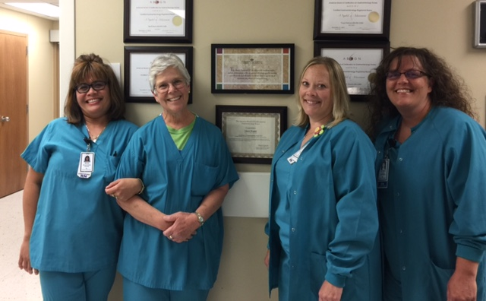

Liberty Hospital has 266 licensed beds. Special Procedures has an annual average census of 4500 of which approximately 2000 are endoscopy patients. Special Procedures also provides care for outpatient infusion/transfusion, injections, pre and post care for cardiology and lithotripsy procedures, therapeutic phlebotomy, rheumatology clinic, cystoscopy, and midline vascular access. There are six full time RNs and two full time GI techs in special procedures.