

6234 South Congress Avenue *suite F1 * Lantana FL * 33462

# **FOR IMMEDIATE RELEASE**

SHENANDOAH MEDICAL CENTER GRAND OPENING

Nurse practitioner owned and operated

The Shenandoah Medical Center is pleased to announce its grand opening on May 20th, 2017 from 11am to 4pm. Shenandoah is a new medical center operating in Lantana Florida. The central focus of the practice is primary and preventive care with on-going education for patient ages 8 years and older.

Shenandoah medical center is owned and operated by Joy Fuller, an advanced registered nurse practitioner. Mrs. Fuller has practiced in this area for over 25 years with experience in primary care, pulmonology, internal medicine and acute care.

*“I feel honored to be able to provide residents in this county with primary care services so they may live optimal lives*” -Joy Fuller, ARNP

The grand opening and ribbon cutting ceremony will highlight the commitment to this community. Blood pressure screening and chair massages will be offered on sight.

In attendance will be representatives from the Palm Beach County Black Nurses Association, Vitas, Serenity Rose and Spa, Isagenix, Independent Imaging.

Representatives from the City of West Palm Beach will be in attendance to present a proclamation.

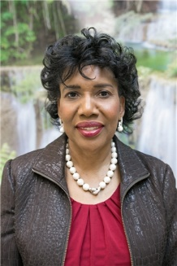*“Chronic care management is also a significant aspect of my practice with respect to patients with diabetes, obesity and hypertension. The goal is to be able to work closely with the community and affect real heath care change “.*

*-Joy Fuller, ARNP*

**For more information, or to RSVP please call 561-619-9510**

**Visit our website at shenandoahmedical.com**