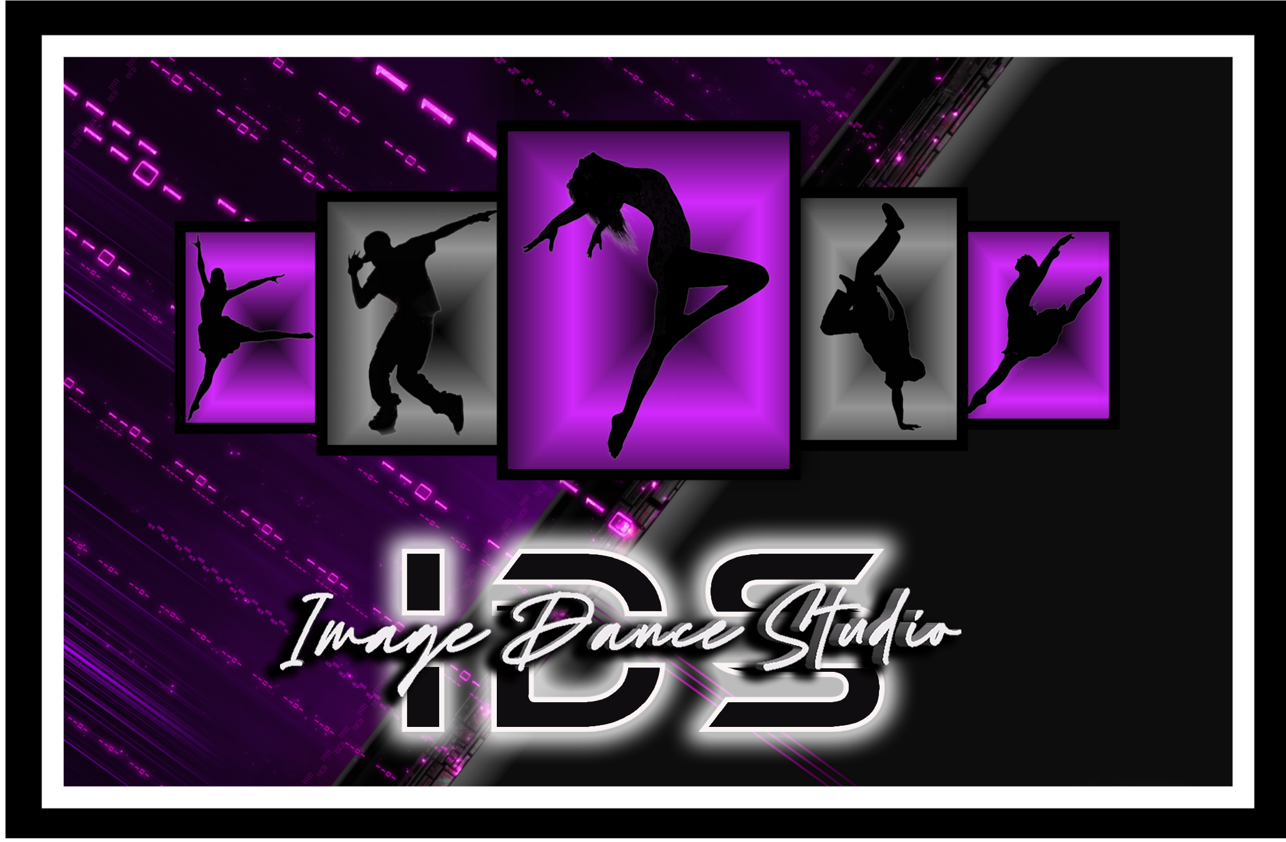

ABOUT US

Welcome to Image Dance Studio offering a unique and diverse schedule of classes including Jazz, Ballet, Hip Hop, Tap, Acro Dance, Contemporary, and Competition Teams. Under the direction of Christa Gonzales since 2007. Christa has taught dance in several schools in the Napa School District for 9 years. She was the Chairperson and Choreographer for the Napa Valley Distinguish Young Women Scholarship Program for 9 years. Christa and her dance partner Chris Navarro were featured in the Fox Television Show "So You Think You Can Dance" Season 7. Christa was the coach for the North Bay Rattler Girls since 2012-2014. The team is a semi-pro cheerleading team and gearing dancers for the NFL or NBA. Christa's love of dance began at the age of 2 years old and has been a huge part of her life. Dancing is something she is very passionate about and loves sharing by teaching dance in the community. Christa believes it's most rewarding when past students of hers make it on high school dance teams or make a career from dance. Image Dance is known for its high energy, creative choreography and challenging classes. Winning 1st place and overall scores at top dance competitions such as"Showstoppers", "Headliners", “Nexstar”, “Starbound", “Rainbow Connection", “Thunderstruck”, "Masquerade" and "Starpower". Image Dance has had the opportunity of performing at local events in Napa and outside the community: "Harvest Goes Broadway", "NVLA Choir Show", "The Napa Christmas Parade" and "Distinguish Young Women Program" , "American Canyon High School Performing Arts Fundraiser", “NVC”, Napa High Jazz Department National Previews Night”, “Napa Valley Care Center”, “Napa Fair”, "North Bay Rattlers Halftime Show" and back-up dancers for the Disneyland Parade "Teen Beach Movie" Spring 2014 and “60th Anniversary Parade 2016”. Image Dance is proud to be a performing studio in the Napa Valley Community. Our program strives to promote confidence and self-esteem within students. We offer classes for all age levels. We have classes for beginning students who have never step foot in a dance studio before. We also offer programs for those who have a series interest in dance and are considering a dance career. Maybe you or your child love dance and you’re looking to take one or more classes a week and enjoy dance for fun. If you’re looking for a challenge and diverse environment in which to grow and develop as a dancer Image Dance is the place for you. We pride ourselves in being a well-rounded studio with instructors who are experts in their specific dance genre in which they teach. We have instructors who are extremely professional. They have B.A. Degrees in Dance & Theater. They have been apart of Dance Companies, Local High School Dance & Cheer Teams, Semi Pro Cheerleading Teams, performed in "Best of Broadway Series", Six Flags Animal Kingdom dancer for the shows and have also had the pleasure of being a back- up dancer for hit stars like Pitbull & Carlos Santana. Some have starred on MTV'S dance show "ABDC” & Fox Television show "SYTUCD".

At Image Dance Studio of Napa is a professional dance studio. We provide you with the best possible training in our dance curriculum program. Image builds confidence, skills, while learning about dance history, helps build friendships and we teach the love of dance. We’re a dance family and our happy for you to join us today!!!

IDS Policy Contract 2025-26

Tuition
(45 Minute- 1 Hour Classes)
- 1 Class $90 per month
- 2 Classes $150 per month (Saving $30)
- 3 Classes $215 per month (Saving $55)
- 4 Classes $275 per month (Saving $85)
- 5 Classes $335 per month (Saving $115)
- Unlimited Classes $400.00 per month
(30 Minute Classes)
- 1 Class $75 per month
- 2 Classes $130 per month (Saving $20)
- 3 Classes $190 per month (Saving $35)
Private Lessons (1 hour)
- Private Lesson $100 per hr (package deals and discount inquire within)
Annual Fee
- IDS Student $45.00 (per student)
**The Annual Fee is good for one dance season October 1, 2025-September 30, 2026**
Tuition Policy
-Tuition is always due by the 1st of each month from October 1, 2025-September 30, 2026. You will receive a receipt via-email once payment has cleared. This may take 3-5 business days. - We currently accept payments only by direct deposit on our website www.imagedancestudio.com If direct deposit is declined a $25.00 fee will be charged and added to your tuition. - Full tuition is due for all months regardless of Holidays or missed classes. - Tuition will be prorated only if you’re a new dancer entering a class after the month has begun.
Late Fee Policy
-There will be a $25.00 late fee assessed if not paid by the 1st. After the 3rd the student will be asked to sit out if payment is not paid in full. By the 30th day if payment in full has not been made you will be asked to drop the class and pay the full payment for the month. Legal action may be taken if not paid.
Drop Policy
- Should you decide to drop out during the dance season October 1, 2025 - September 30, 2026, you must sign a “Drop/ Withdraw Class Form”. Please fill form out and turn in before the 15th the prior month. Any dropped classes or withdrawals not turned in by the deadline will incur tuition or Master Class charges and will be invoiced for the next month or future months until form is received. You’re responsible for this. Drop Form can be found online at www.imagedancestudio.com and please email it to us at image-dance@hotmail.com

Dance Class Placement Policy
Your child will be placed in a technique class due to prior or no dance experience by Christa. There will be a trial class offered to assets the level of the dancer and properly place the dancer. Christa and the instructor of the class will discuss the placement after the dancer has completed the class. We will be happy to discuss after the class. A child can move up in a dance class anytime during the year by recommendation from Christa and the dance instructor. At Image Dance Studio we want the student to feel comfortable in their classes but also challenge them at the same time. Any concerns or questions about this please see Christa. At the end of
the dance season the student will be tested out of a class and could be moved up in class level.

Required Classes ***For Intermediate-Advance classes you must take the following additional classes along with Master Classes that are offered once a month***

Jazz (Intermediate -Advance) – Ballet & Acro Contemporary (Beginning-Advance) – Ballet & Acro Hip Hop (Intermediate-Advance) – Acro
Master Classes All Intermediate-Advance Technique Classes and Competition Jr & Sr Team members are required to take Master Classes in their technique once every other month. The class can be $25-$35 per month depending on who we bring in. The Master Class payment will be added on the 1st of the month along with tuition. Master Class payment is required regardless of a dancer cannot attend during any part of the season. There is no credit towards another Master Class if you cannot attend. You will have to do a make-up class advised by Christa and will be charged for the additional class.

Dance Curriculum
For each class you take you will learn technique, styles, dynamics, formations, history, vocabulary, and choreography. There will be three tests given to students in the three breaks in the season from October 1, 2025-September 30, 2026: (Test 1 Week December 15th-18th) / (Test 2 Week May 18th-22nd)/ (Overall Test 3 August 10th-14th). Each student will be tested overall in test #3. A letter and email will be sent to their parents on class placement afterwards for the following dance season.

Dress Code Policy
***No Jeans, Jewelry, Crocks & Non-Dance Shoes such as slip-on ballet flats allowed***
***All girls must have hair up in a ponytail or bun***

Ballet: Black leotard, pink or tan tights and Ballet Shoes. Hair must be worn in a tight bun for all classes. No messy buns. (No bra straps, undergarments, or shorts)
Jazz: Jazz pants, spandex shorts, tank top or t-shirt, jazz shoes and hair in ponytail Hip Hop: comfortable pants, shirt or tank-top and tennis shoes or sneakers must be worn. Hair in Ponytail Contemporary: Comfortable sweat or jazz pants, spandex shorts, t-shirt or tank top, jazz shoes or bare feet. Hair in ponytail.
Acro: Leotard, leggings, shorts, tank top or shirt. Barre foot or half socks. Hair in ponytail.
Please come to class dressed before hand. If a dancer is not in dance dress attire. They will be asked to sit out of class that day. Please make
sure to follow dress code for all classes!!!

Attendance/ Arriving Late/ Picking up Policy
- There will be 5 excused absences per class allowed from each quarter of the season: October 1, 2025-December 31, 2025/ January 1, 2026- June 5, 2026/ June 6, 2026-September 30, 2026. If your child misses more than 5 classes in one quarter, there will be a discussion with Christa and the dance teacher for that class with the parent.
-We ask if your child becomes ill or you will miss a class. Please contact Christa by
email or phone so she can notify the instructor for your child’s classes.
-Make sure to arrive on time for classes. At Image Dance we understand things happen that may allow you to be late. Please arrive on time dressed and ready for class so you do not disrupt the class. If you are running late, please call to notify us beforehand at 707-738-6556. Please leave a voice message or text.
- Please do not come more than 15 minutes early when the studio opens for its first class of the day.
- Please make sure to pick up students on time. We ask that students please wait inside when being picked up from the studio.

Unaccepted Behavior
As a member of Image Dance Studio, any unacceptable behavior while attending classes could be asked to leave the studio.
- No inappropriate language
- No verbal or physical abuse to a fellow student or instructor
- No use, possession, or distribution of drugs and / or alcohol
- No smoking allowed
- No weapons
- No theft
- No vandalism or defacing of studio property
8) No inappropriate behavior on any social network, pictures, video, or comments used
9) No Attitude
10) No asking a teacher to you give you a ride to or from dance studio
11) No Stealing choreography from Image Dance Studio instructors or guest choreographers. Legal action could be taken!!!!!
12) No slander towards the studio, staff, dancer, or parent in person, at an IDS event or on any social media accounts. You will be asked to leave and not come back to our studio. We have no tolerance for this.

Studio Etiquette Policy
-Please no food or any drinks allowed on the dance floor unless it’s water.
- No gum allowed when dancing.
- When coming into the studio please be aware classes are going on and we are asking for everyone to please use inside voices and do not disrupt classes that may be going on.
- Dance students please put all personal belongs in the cubbies.
- Please gather all belongs and make sure you pick up any clothing items, jewelry, phones, etc. Image Dance Studio is not responsible for lost or stolen items. If you leave something at the studio you will have one week to claim it, or it will be given to Good Will.
- Please be courtesy to our instructors, other dance members and parents at Image Dance Studio. We want to keep a positive environment for everyone.
- No sibling or friends allowed to be left alone without an adult if you’re under the age of 14.
- No touching screens or opening windows unless instructed.
- No touching or leaning against the dance mirrors or studio wall with sign.

Discussion Policy
If there is a series concern or problem that needs to be discussed in person, please arrange a meeting with Christa. All issues will not be addressed in person without a meeting. When scheduling meeting please contact us by phone, email or at the studio.

Video & Photo Policy in Classes or Events
Please ask permission from Instructors, Students & Parents before taking pictures or video on our monitors or if the dance doors are open during class. We want to respect all dancers’ privacy at the studio & to feel safe. Please do not post any photos or videos from class on any social media regardless of consent given by Instructors, Students & Parents. If found on any social media without Christa consent, you may be asked to leave the studio. We at Image Dance Studio appreciate your support in this matter.

Recital Policy
We offer a Dance Recital at the end of the dances season. Costume Payments are the responsibility of the parents. All costume deposits are non-refundable regardless of you dropping a dance class. If payment is not received on the due date your costume will not be ordered. You will be billed for costumes once you sign the registration form for the Image Dance Studio Season October 1, 2025-September 30, 2026. If you leave the studio before the costumes our handed out it will be your responsibility to pick up the costume. Image Dance Studio will hold costume for 6 months only. We also do recital pictures at the dance studio in August. Cost for pictures is $100-$150. Payment is not due till August 15th

September 2024 Dance Recital: (ages 3-6) under $55-$65
(ages 7 & up) under $65-$85
Payment Due: April 1, 2026
***Costumes will not include shoes. You’re responsible for providing dance shoes. Costumes will be paid through automatic withdraw through our website system. *** Please refer to costume list when emailed in November. An email will be sent out with a detailed list of hair, make-up, and costume info.

Recital & Dress Rehearsal Attendance Policy
Please make it appoint to be in class. Each week you will be learning new material for your recital routine. If we notice a student missing three or more classes in a row you may ask to not be in a section. If a student misses 5 absences or more in a semester this may result in the student being taken out of a section of the routine or the whole thing especially towards the end of the year closer to recital time. Please you must be at the dress rehearsal to be in the show. Its mandatory all dancers be at dress rehearsal.

Dance Recital Pictures
We will be having a picture day at the studio for the dance recital routines in August. Dancers will have the opportunity to take group and individual shots with Image Dance Studio hired photographer. Once date and times are released to everyone, please save the date and information. There will not be any rescheduling of pictures or change of times for that day if dancer cannot attend.

Owner/ Director: Christa Gonzales
Address: 849 Jackson Street Suite #1C Napa, Ca 94559
Phone #: 707-738-6556
Email: image-dance@hotmail.com
Website: www.imagedancestudio.com
Facebook: @Imagedancestudio / Instagram: @Imagedancestudio/ Tik Tok: @Imagedancestudio / YouTube: Image Dance Studio

Policy Contract 2025-26

By signing below, I have read and understood all policies at Image Dance Studio for the season October 1, 2025-September 30, 2026: Tuition Policy, Annual Fee Policy, Late Fee, Drop Policy, Dance Class Placement Policy, Required Class Policy, Dance Curriculum, Dress Code Policy, Attendance /Arriving Late/ Picking Up Policy, Unacceptable Behavior, Studio Etiquette, Discussion Policy, Recital & Dress Rehearsal Attendance Policy, Costume Payment, and Video/ Photo Policy.

I _________________________ Parent (Under 18 years old) or Student have read and understand the Image Dance Studio Policy Contract. I’m committed and will do what is required from the studio.

Parent Signature (Under 18 years old): ____________________________________

Print Name: __________________________________ Date: ________________

Dancer Signature: ______________________________________

Print Name: __________________________________ Date: _______________

Media Release Form

Permission will be given to Image Dance Studio to use dance related photos or videos of dancer for advertisement purpose for current season and future seasons ahead regardless of dancer is no longer at Image Dance Studio. This includes the studio rooms, the studio website, fliers, banners, brochures, ads, all social media accounts such as: Facebook, Instagram, Tik Tok YouTube, and Twitter.

I _________________________Parent (Under 18 years old) or Student have read and understand the Image Dance Studio media release form. By signing below, I release rights to Image Dance Studio to advertise dance related photos or videos of my child or myself.

Parent Signature (Under 18 years old): ____________________________________

Print Name:__________________________________ Date: ________________

Dancer Signature: ______________________________________

Print Name: __________________________________ Date: _______________

