**Module 5: The Changing Face of America’s Veteran**

**2 Timothy 2 New King James Version**

**You therefore, my son, be strong in the grace that is in Christ Jesus. 2And the things that you have heard from me among many witnesses, commit these to faithful men who will be able to teach others also. 3You therefore must endurehardship as a good soldier of Jesus Christ.**

November 10, 2017

**The changing face of America’s veteran population**

**By** [**Kristen Bialik**](https://www.pewresearch.org/staff/kristen-bialik)

[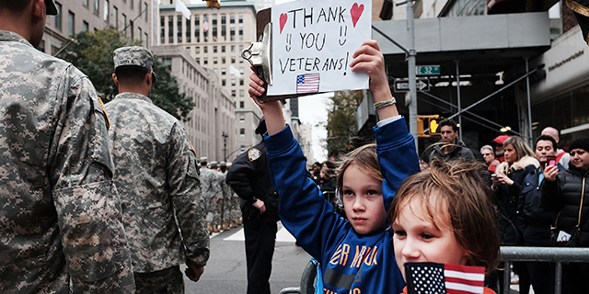](https://www.pewresearch.org/fact-tank/2017/11/10/the-changing-face-of-americas-veteran-population/ft_17-11-09_veterans_featured-image/)Gavin Kinney, left, and his brother Rigel hold up a sign at the New York City Veterans Day Parade on Nov. 11, 2015. (Spencer Platt/Getty Images)

There were around 20.4 million U.S. veterans in 2016, according to data from the [Department of Veterans Affairs](https://www.va.gov/vetdata/veteran_population.asp), representing less than 10% of the total U.S. adult population. As Americans observe Veterans Day, here are key facts about those who have served in the military and how this population is changing.

[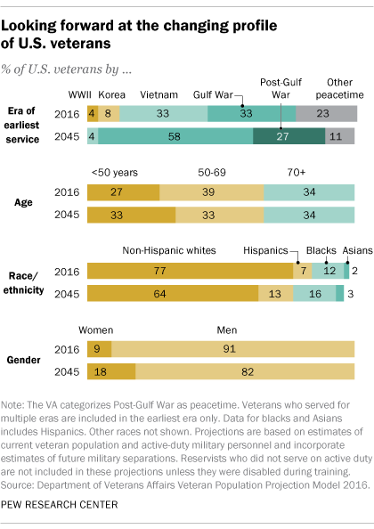](https://www.pewresearch.org/fact-tank/2017/11/10/the-changing-face-of-americas-veteran-population/ft_17-11-09_veterans/)

**1. Gulf War-era veterans now account for the** [**largest share**](https://www.va.gov/vetdata/docs/Demographics/New_Vetpop_Model/Vetpop_Infographic_Final31.pdf) **of all U.S. veterans,** surpassing Vietnam-era veterans in 2016, according to [Veterans Affairs’ 2016 population model estimates](https://www.va.gov/vetdata/veteran_population.asp). As of last year, there were 6.8 million American veterans who served during the Vietnam era and 7.1 million who served in the Gulf War era, which spans from August 1990 through the present. (Some veterans served through both eras.) There were also around 771,000 World War II veterans and 1.6 million who served during the Korean conflict, the VA estimates. About three-quarters (77%) of veterans in 2016 served during wartime and 23% only served during peacetime.

**2. The share of the U.S. population with** [**military experience**](https://www.pewresearch.org/fact-tank/2016/11/11/profile-of-u-s-veterans-is-changing-dramatically-as-their-ranks-decline/) **is declining.** In 2016, 7% of U.S. adults were veterans, down from 18% in 1980, according to the [Census Bureau](https://factfinder.census.gov/bkmk/table/1.0/en/ACS/16_1YR/S2101). This drop coincides with decreases in active duty personnel. Over the past half-century, the number of people on [active duty](https://www.pewresearch.org/fact-tank/2017/04/13/6-facts-about-the-u-s-military-and-its-changing-demographics/) has dropped significantly, from 3.5 million in 1968, during the draft era, to [1.3 million](https://www.dmdc.osd.mil/appj/dwp/dwp_reports.jsp) (or less than 1% of all U.S. adults) in today’s all-volunteer force. The military draft ended in 1973.

VA projections suggest the number of veterans will continue to decline in the coming decades. By 2045, the department estimates there will be around 12 million veterans, a roughly 40% decrease from current numbers. By that time, Gulf War-era veterans are projected to make up a majority of veterans, and most of those who served in the Vietnam era or earlier will have died.

**3. The** [**demographic profile of veterans**](https://www.pewresearch.org/fact-tank/2016/11/11/profile-of-u-s-veterans-is-changing-dramatically-as-their-ranks-decline/) **is expected to change in the next few decades.** Currently, nine-in-ten veterans (91%) are men while 9% are women, according to the VA’s 2016 population model estimates. By 2045, the share of female veterans is expected to double to 18%. The number of female veterans is also projected to increase, from around 1.9 million in 2016 to 2.2 million in 2045. Male veterans, on the other hand, are projected to drop by almost half, from 18.5 million in 2016 to 9.8 million in 2045. Projections also indicate that the veteran population will become slightly younger by 2045, with 33% of veterans younger than 50 (compared with 27% in 2016), even as the overall U.S. population continues to age. The share of veterans ages 50 to 69 is expected to shrink from 39% to 33%, while the share of those 70 and older is predicted to be around a third of the total (34%) by 2045, similar to the current share.

As with trends in the U.S. population overall, the veteran population is predicted to become more racially and ethnically diverse. Between 2016 and 2045, the share of veterans who are non-Hispanic white is expected to drop from 77% to 64%. The share of veterans who are Hispanic is expected to nearly double from 7% to 13%, while the share who are black is expected to increase from 12% to 16%.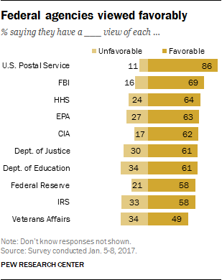

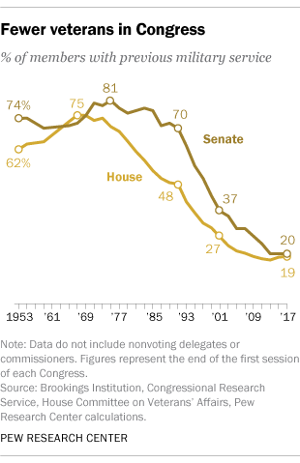

**4. Fewer members of Congress have prior military experience than in the past.** As the share of Americans who are veterans has declined, so has the share of Congress members who have previously served in the military. In the [current Congress](https://www.pewresearch.org/fact-tank/2017/02/02/the-changing-face-of-congress-in-5-charts/), 20% of senators and 19% of representatives had prior military service, down drastically from just a few decades ago. The share of senators who are veterans reached a post-Korean War peak of 81% in 1975, while the share among House members peaked in 1967 at 75%. However, there are [signs more veterans could run for office](https://www.npr.org/2017/09/08/549172533/with-an-eye-on-the-house-democrats-turn-to-veterans-for-2018-races) in the future.

**5. The Department of Veterans Affairs receives a low favorability rating.** While the public expresses favorable views of many federal agencies, the VA received the lowest rating among 10 agencies and departments in a [Pew Research Center survey](https://www.people-press.org/2017/01/19/on-eve-of-inauguration-americans-expect-nations-deep-political-divisions-to-persist/#most-view-fbi-cia-doj-and-other-agencies-favorably) earlier this year. Roughly half of U.S. adults (49%) had a favorable view of the VA and 34% expressed an unfavorable view. As with all the agencies and departments in the survey, there were partisan differences. Republicans and Republican-leaning independents expressed lower favorability for the VA (40%) than Democrats and Democratic leaners (60%).

Americans continue to see veterans’ services as an important priority. In an [April survey](https://www.people-press.org/2017/04/24/with-budget-debate-looming-growing-share-of-public-prefers-bigger-government/), a majority of people (75%) said that if they were making the federal budget, they would increase spending for veterans’ benefits and services – the highest share of all 14 program areas included in the survey, as well as the highest level of support for increased spending on veterans services since Pew Research Center first asked the question in 2001.